EXTENSION PUBLICATION NO. AU/DEx/498-Bl/07/2026


KRISHI VIGYAN KENDRA (KVK)
GUREZ

Custom Hiring Centre (C-H-C) at KVK Gurez:
One stop solution for increasing efficiency, reducing farm drudgery

Chief Patron
Prof. Nazir Ahmad Ganai
Hon’ble Vice-Chancellor

Patron
Prof Raihna Habib Kanth
Director Extension

Directorate of Extension
Sher-e-Kashmir University of Agricultural Sciences &Technology of Kashmir

Introduction
Agriculture has evolved from labour-intensive practices to a more mechanized and efficient system due to increasing labour shortages and the high cost of maintaining draught animals. Mechanization improves crop productivity, reduces drudgery, ensures timely farm operations, and supports activities such as land preparation, sowing, irrigation, plant protection, harvesting, threshing, and post-harvest management.
In Gurez valley, mechanization is constrained by geographical isolation, rugged terrain, fragility, marginality and inaccessibility small landholdings, with short cropping season (May-Oct). It also reduces drudgery, especially for women, as most of the agricultural activities are being carried out by women farmers. However, access to machinery remains limited for small and marginal farmers due to various constraints like area of operation, budget, formal procedures etc. To bridge this gap, Custom Hiring Centres (CHCs) have been promoted under the Holistic Agriculture Development Plan (HADP) to provide affordable access to agricultural machinery across the Gurez valley.
As part of this initiative, one such CHC has been set up at Krishi Vigyan Kendra, Gurez under the HADP-9 project titled “Farm Mechanization and Automation.” This centre aims to cater to the mechanization needs of local farmers and improve access to modern agricultural practices.
Objectives:
- To make various farm machinery and equipment accessible to small and marginal farmers.
- To offset the high cost of individual ownership and reduce the adverse effects of economies of scale.
- To enhance mechanization in regions with low availability of farm power.
- To expand the use of mechanized operations across large areas during cropping seasons, particularly in small and marginal holdings.
- To provide hiring services for high-value, crop-specific machinery required for different agricultural operations.
- To introduce improved and newly developed agricultural implements and machines in crop production.
CHC Unit:
The Custom Hiring Centre established at Krishi Vigyan Kendra, Gurez includes farm machinery that is widely used for various agricultural activities such as tillage, sowing and planting, intercultural operations, plant protection, harvesting and threshing as under.
Table 1: Showing the details of available farm machinery for custom hiring/ lease at KVK Gurez
S. No. | Name of Machinery/Equipment | Model | Importance & Benefits for Farmers
1 | Tractor 4WD (27.5 HP) | Mahindra 2127 OJA | Core power unit for multiple operations; enhances productivity; suitable for hilly & rugged terrain.
2 | Single Speed Agriculture Rotavator | Agrigate MRT 424 | Efficient soil preparation; saves time and labor compared to manual or traditional methods.
3 | Spring Loaded Cultivator (5 Tyne) | PAGRO PCSTSL | Breaks hard soil clods; improves soil aeration and moisture retention.
4 | Self-Propelled Weeder (Walk-Behind) | FALCON FRTC-2015H | Ideal for small fields; reduces drudgery; cost-effective for inter-row weed management.
5 | Potato Planter (Tractor Operated) | VEER MECHANICAL IEW SAPP-F | Ensures uniform planting; increases efficiency and productivity in potato cultivation.
6 | Brush Cutter | Naptune HONDA GX35 | Handy for cutting grass, weeds, and shrubs; suitable for undulating terrain; reduces manual effort.
7 | Maize Dehusker cum Sheller | MATLEX MDE-10 | Saves time and labor in maize processing; reduces grain loss.
8 | Potato Digger (Tractor Operated) | VEER MECHANICAL IEW SNPD-2R | Enables faster harvesting; reduces crop damage compared to manual digging.
9 | Spike Tooth Multi-Crop Thresher for Cereals | UMIYA UAI G-6 | Suitable for threshing multiple crops (wheat, barley, etc.); enhances post-harvest efficiency.
10 | Tractor Trolley (Semi Trailer with Tipping Platform, 4 Tonne) | UVAI-SATT-01 | Easy transport of inputs and outputs; improves logistics and reduces turnaround time.
11 | Self-Propelled Reaper | Kisancraft KK-SPR-1201P | Speeds up harvesting of cereals; reduces dependency on labor.

Potential for mechanization through Custom Hiring Centres(CHC):
Farm power availability is quite limited in small and marginal landholdings. As these holdings account for nearly 70–80% of the total landholdings, there is a substantial potential for Custom Hiring Centres (CHCs) to fulfill the farm machinery requirements of the region. Recognizing this potential, the Government of Jammu and Kashmir has envisioned increasing the farm power availability in the Union Territory from the present level of 1.56 kW/ha to 2.5 kW/ha during 2023–2027 under the Holistic Agriculture Development Plan.
Moreover, subsidy schemes are being formulated to motivate entrepreneurs and agriculture graduates to establish CHCs. Therefore, in view of the increasing emphasis on farm mechanization and the need to make agricultural machinery accessible to small and marginal farmers, the establishment of CHCs in each block of the Union Territory has been initiated. And ideally, a Custom Hiring Centre (CHC) should be located in an area where a majority of small landholdings fall within a radius of 5–7 km. In other words, one CHC is expected to serve about 4–5 villages. Accordingly, a CHC has been established at Dawar, Gurez to cater to the surrounding villages.
Direct-Farmer-Benefit:
Farmers, particularly small and marginal landholders, face several challenges that hinder the adoption of agricultural mechanization. Poor resources limit their ability to invest in modern farm machinery, while a lack of knowledge regarding different government schemes prevents them from accessing available benefits. Their low risk-bearing capacity discourages investment in new technologies, and being unskilled in farm operations further restricts the efficient use of machinery. Additionally, institutional issues coupled with long and difficult access to farm machinery, delay timely farm operations, reduce productivity, and ultimately impede sustainable agricultural development. Therefore, a CHC has been established at KVK Gurez, to provide agricultural machinery on rent or lease basis at approved nominal custom hiring charges as given under.
Table 2:- Showing the details of Custom hiring out charges of the selected farm machinery
S.No. | Name of Implement | Rs/hour | Rs/kanal | Leased value (Rs/day)
1 | Tractor | 885/- | - | -
1 | with cultivator | 915/- | 200/- | 500/-
1 | with rotavator | 950/- | 220/- | 500/-
1 | disc plough | 1200/- | 350/- | 500/-
1 | with trolley | 915/- | - | 500/-
2 | Tractor drawn seed drill | 1000/- | 300/- | 500/-
3 | Irrigation pump (Honda) | 150/- | - | 200/-
4 | Self-propelled power weeder | 200/- | 300/- | 500/-
5 | Brush cutter (engine operated) | 100/- | - | 300/-
6 | Maize sheller (motorized) | 50/- | 2.0 (Rs/kg cobs) | 250/-
7 | Self-propelled reaper | 300/- | 400/- | 500/-
8 | Tractor operated multi-crop thresher | 1100/- | 4000/- | 300/-
9 | Tractor drawn potato planter | 1100/- | 500/- | 500/-
10 | Tractor drawn potato digger | 1100/- | 500/- | 500/-
Note: The leased value of farm implements is without tractor/power source.
Income and Expenditure:
The primary source of income for the CHC is derived from the minimum charges being received from farmers against mechanized services. The recurring expenditures include fuel and lubricant costs, operator/driver charges, repair and maintenance expenses, labour costs, and insurance. Thus, the CHC will manage its expenditures from the income generated through custom hiring.
Implementation of CHC:
Head and team KVK Gurez have been entrusted for effective implementation of C-H-C while a separate revolving fund account has been created for efficient operations. Farmers on village/ community basis seeking services used to submit a requisition for some specific prototypes following all formalities for management and utilization. The billing amount thus generated is being deposited in designated accounts. Thus, farmers are getting benefits through mechanized system of prototypes thereby helping increase efficiency, ensure profitability, reduce drudgery and facilitating in changing the quality of life in the long run.

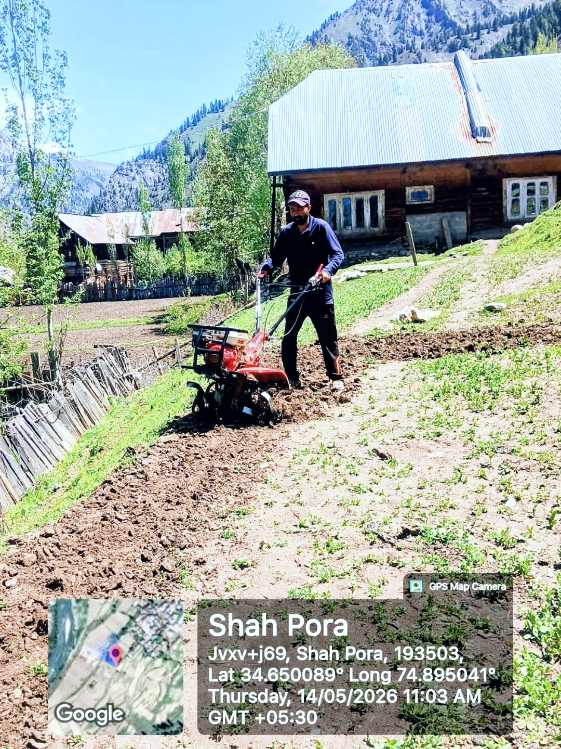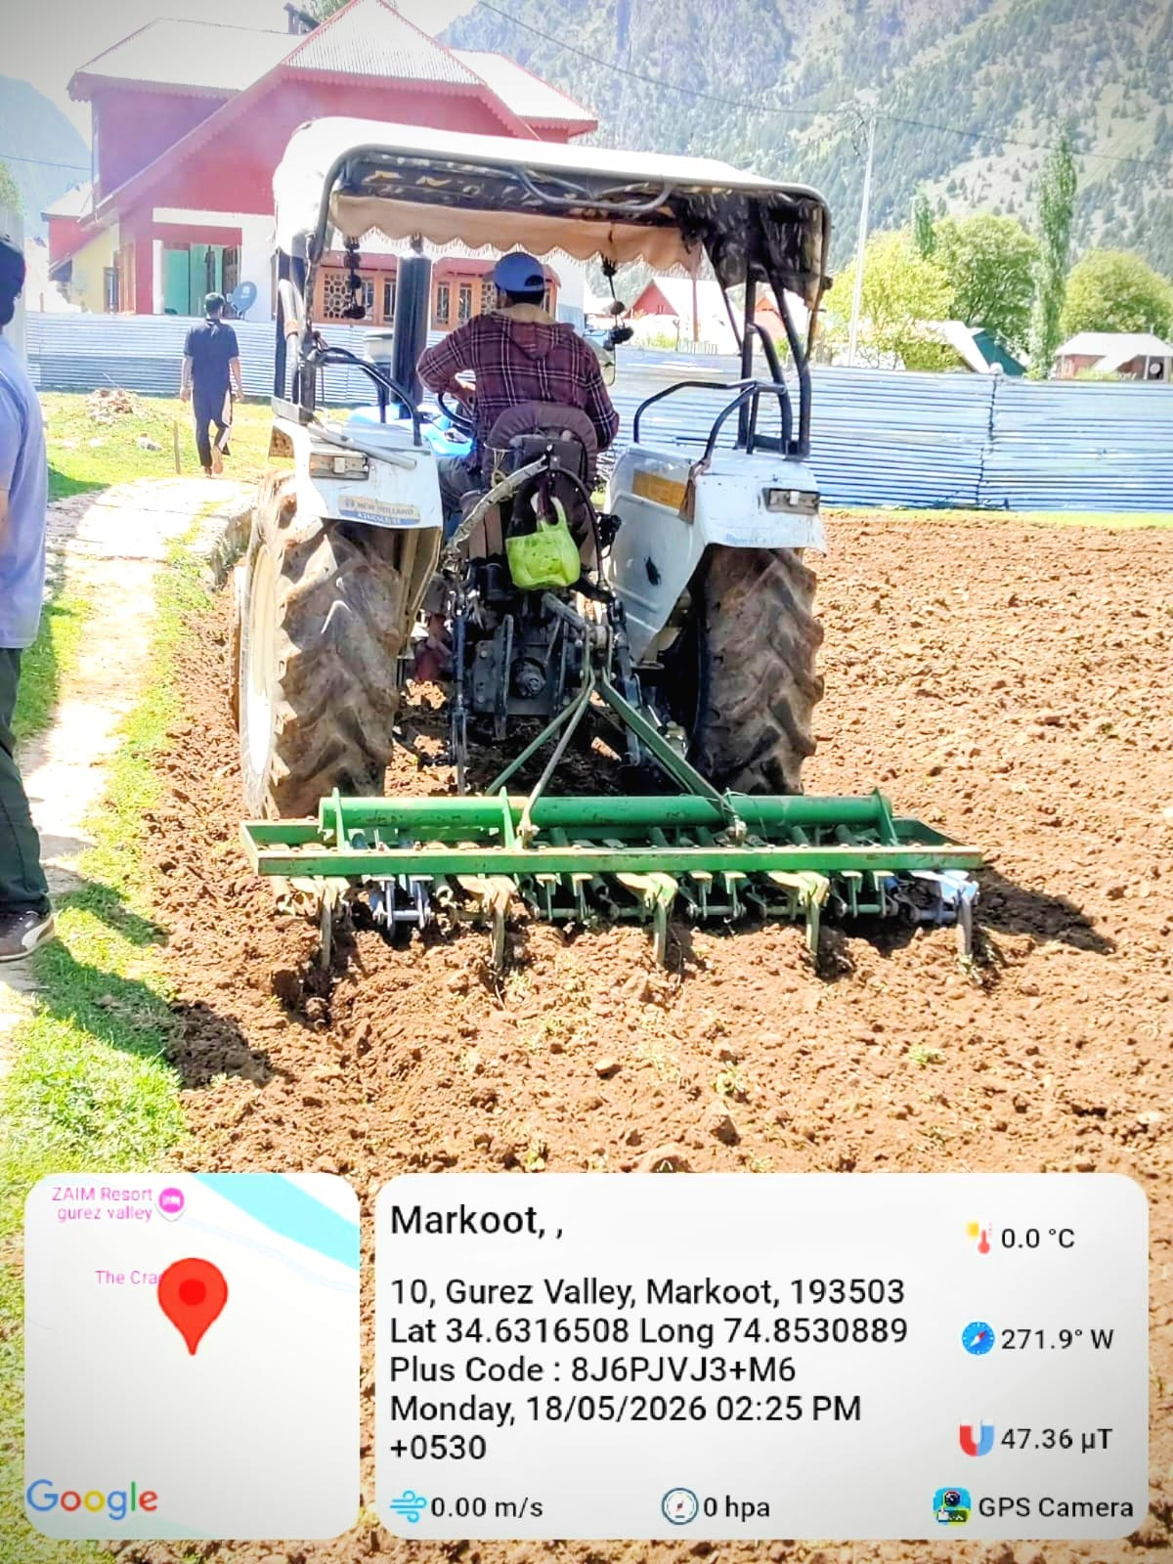
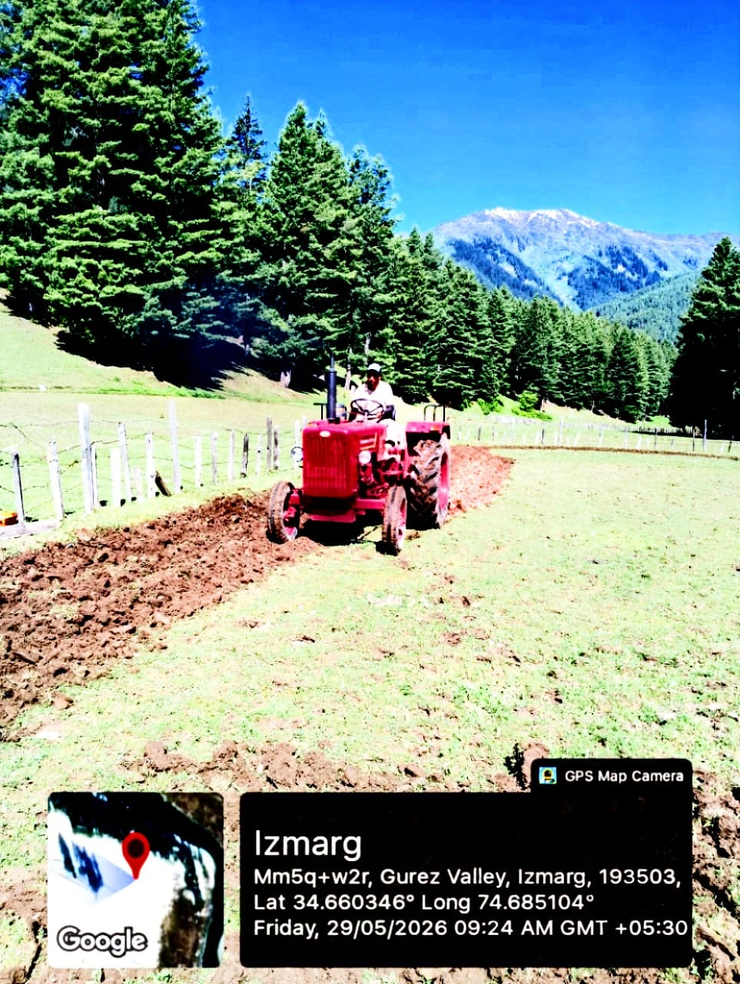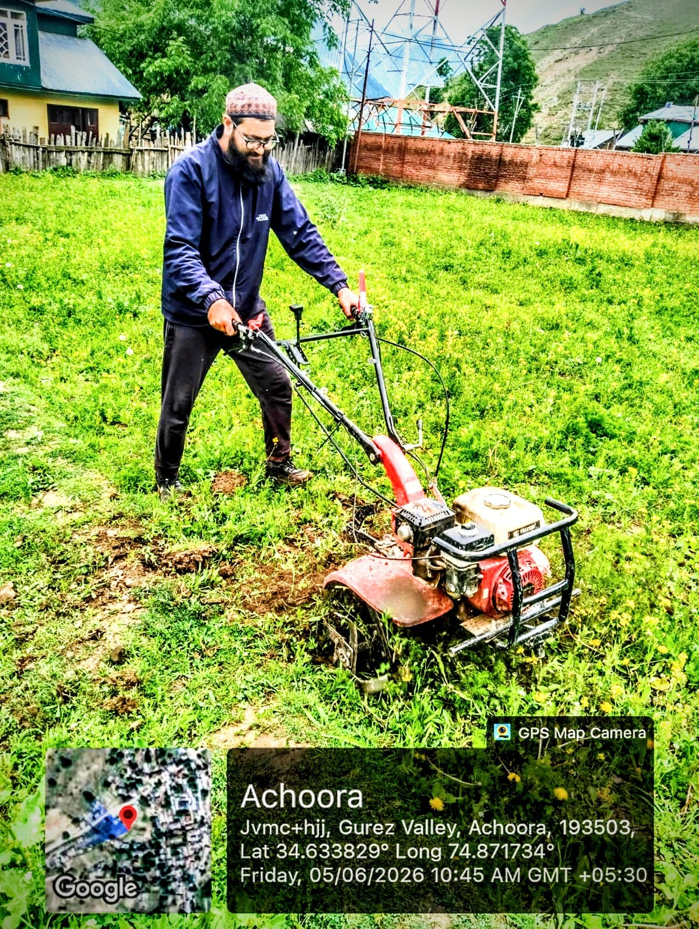
Glimpses of C-H-C Facilities availed by Farmers

Authors:

Mr. Ravi Kumar
(Farm Manager)

Dr. Hilal Ahmad Malik
Head KVK Gurez

Dr. Jauhar Rafeeq
Scientist (Agroforesty)

Dr. Shahida Altaf
Scientist (Plant protection)

Mr. Manzoor Ahmad Khatana
Programme Assistant (lab)

Mr. Tanzeer Hussain Khan
Programme Assistant (Computers)

Krishi Vigyan Kendra (KVK) Gurez

Directorate of Extension

Sher-e-Kashmir University of Agricultural Sciences and Technology of Kashmir
******

