

EXTENSION FOLDER NO. AU/DEx/496-Bl/07/2026
KRISHI VIGYAN KENDRA
GUREZ

Medicinal & Aromatic Plant (MAPs) Resources of Gurez Valley:
An instrument Towards Traditional Healing Practices
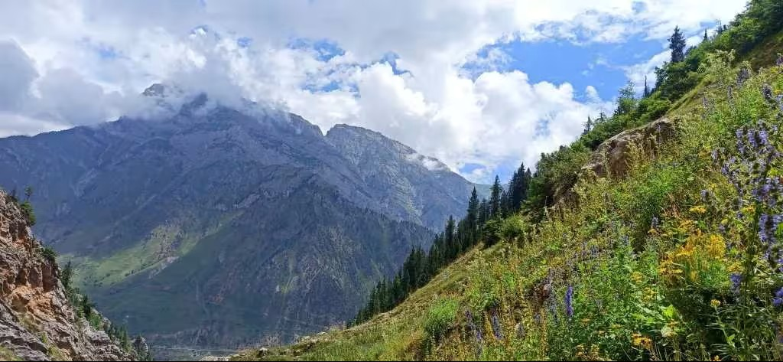
Chief Patron
Prof. Nazir Ahmad Ganai
Hon’ble Vice chancellor

Co- Patron
Prof Raihana Habib Kanth
Director Extension
Directorate of Extension
Sher-e-Kashmir University of Agricultural Sciences and Technology of Kashmir

MAPs of Gurez: A Bird’s Eye view
Gurez Valley, situated in the high-altitude landscapes of the Kashmir Himalaya, is renowned for its pristine environment, rich biodiversity, and unique cultural heritage. The valley encompasses a wide range of habitats, including alpine meadows, sub-alpine pastures, riverine ecosystems, and temperate forests, which collectively support a diverse assemblage of medicinal and aromatic plants. For generations, the inhabitants of Gurez have depended upon these natural resources to meet their healthcare needs, developing a rich repository of traditional knowledge on the therapeutic uses of local flora.
Medicinal plants form an integral part of the traditional healthcare system of the valley. Local communities possess extensive knowledge regarding the identification, collection, preparation, and application of herbal remedies for the treatment of various ailments. These remedies are commonly used to manage respiratory disorders, digestive complaints, liver diseases, fever, wounds, rheumatism, urinary problems, skin infections, and reproductive health issues. Such indigenous knowledge, accumulated through centuries of observation and experience, represents an invaluable cultural and biological heritage.
The valley is home to several high-value medicinal plant species. These species are highly prized in traditional systems of medicine and contribute significantly to rural livelihoods through their medicinal and economic value. However, increasing anthropogenic pressure, unsustainable harvesting practices, habitat degradation, and changing climatic conditions pose serious threats to many of these valuable species. Conservation of medicinal plant diversity, promotion of sustainable harvesting practices, and preservation of traditional knowledge have therefore become critical for safeguarding these resources for future generations.
This booklet presents a compilation of important medicinal plants recorded from Gurez Valley, highlighting their local names, traditional uses, and significance in indigenous healthcare systems. It seeks to document and celebrate the ethnobotanical heritage of the region while promoting awareness about the conservation and sustainable utilization of medicinal plant resources. By bridging traditional wisdom with scientific understanding, this publication aims to contribute towards biodiversity conservation, community well-being, and the sustainable development of the Himalayan region.
KVK Gurez Interventions for Promotion of MAPs in Gurez Valley
Gurez Valley harbours a rich diversity of medicinal and aromatic plants with immense ecological, medicinal, and economic value. However, many of these high-value species are under severe threat due to indiscriminate and unsustainable harvesting from wild populations, habitat degradation, limited awareness regarding conservation, and the lack of systematic documentation of traditional ethnomedicinal knowledge. Despite their high market demand and significant potential to enhance rural livelihoods through cultivation, value addition, and entrepreneurship, these resources remain largely underutilized. Recognizing these challenges and opportunities, KVK Gurez has initiated focused interventions to document traditional knowledge, conserve threatened germplasm, promote scientific cultivation, and build the capacity of local communities, thereby ensuring biodiversity conservation while unlocking the economic potential of medicinal and aromatic plants for sustainable livelihood development.
Documentation of Traditional Knowledge
Recognizing the immense medicinal, ecological, and economic significance of Medicinal and Aromatic Plants (MAPs), KVK Gurez has initiated systematic field surveys across different habitats of Gurez Valley to document the region's rich medicinal plant wealth. The initiative focuses on identifying and recording indigenous medicinal plant species, their traditional uses, distribution patterns, population status, and conservation needs. Special emphasis is being placed on high-value Himalayan medicinal plants that form an integral part of the traditional healthcare system and livelihood security of local communities. As part of this effort, KVK Gurez is documenting traditional knowledge associated with medicinal plants through interactions with local elders, traditional healers, shepherds, and farming communities. Simultaneously, studies on population ecology are being undertaken to assess species abundance, habitat preferences, regeneration status, and threats affecting natural populations. These surveys are generating valuable baseline information for the conservation and sustainable management of medicinal plant resources in the valley.
Establishment of MAPs Germplasm Bank
To conserve the rich medicinal plant diversity of Gurez Valley, KVK Gurez has established a Medicinal and Aromatic Plants (MAPs) Germplasm Bank for the collection, conservation, and propagation of important medicinal species. The germplasm bank serves as a repository of high-value and threatened Himalayan medicinal plants, ensuring the preservation of their genetic resources for future generations. It also provides quality planting material, supports research and demonstration activities, and promotes the cultivation of medicinal plants among farmers and rural youth as a sustainable livelihood option while reducing pressure on wild populations.
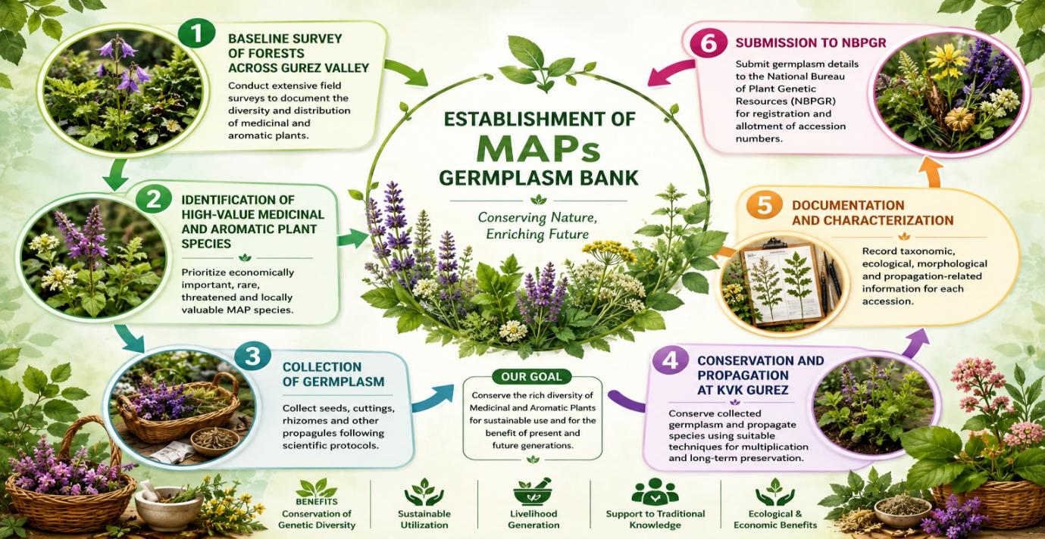
Workflow for Conservation of High-Value Medicinal and Aromatic Plants
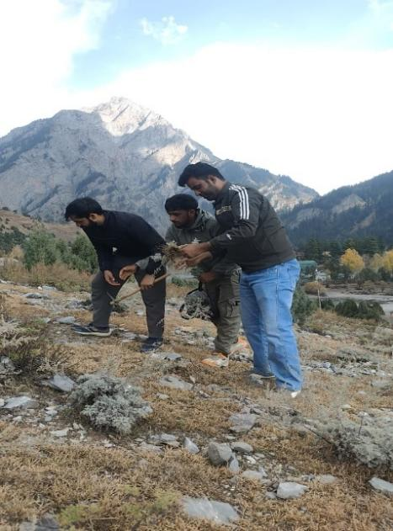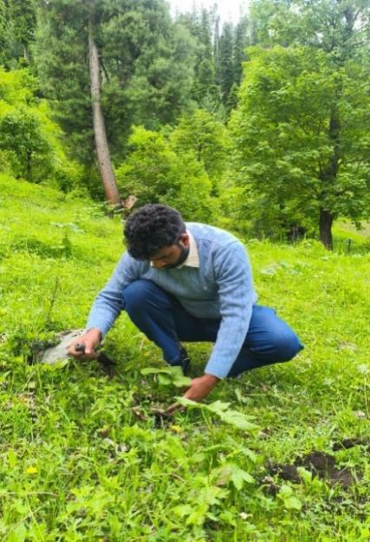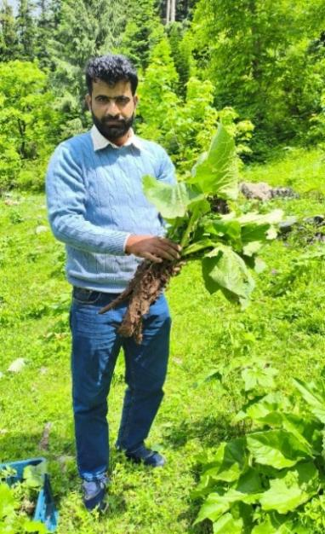
Species Collection

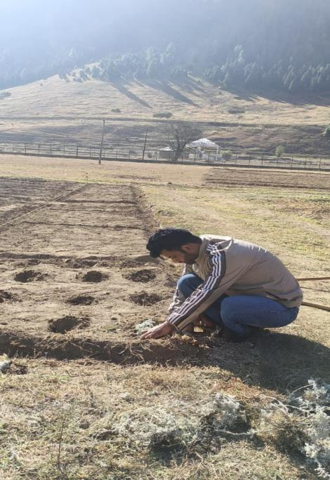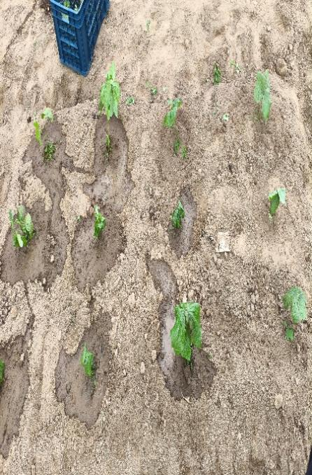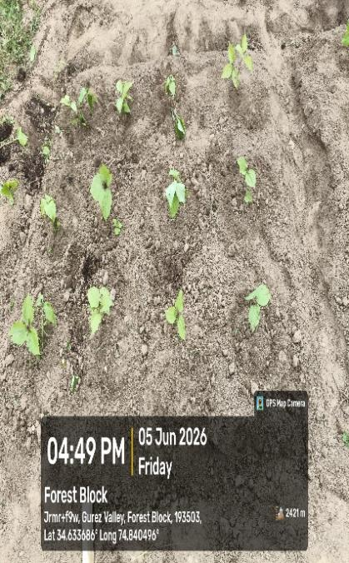
Bed Preparation and Transplanting of Species
Knowledge based, Skill oriented Capacity Building Programmes
To promote livelihood diversification and entrepreneurship, KVK Gurez is also conducting continuous awareness and capacity-building programmes for farmers and educated youth interested in the cultivation, processing, and value addition of medicinal and aromatic plants. Through training programmes, field demonstrations, exposure visits, and technical guidance, local stakeholders are being encouraged to adopt MAP cultivation as a sustainable income-generating enterprise. These efforts aim to reduce pressure on wild populations while creating new opportunities for employment, rural development, and biodiversity conservation in the remote Himalayan landscapes of Gurez Valley.
Major Capacity Building Programmes Conducted on Medicinal and Aromatic Plants by KVK Gurez
S. No. | Name of Training Programme | Funding/Sponsoring Agency | Duration | No. of Programmes
1 | Management of Cultivation, Processing and Marketing for Entrepreneurship Development in Medicinal Plants of Gurez Valley (EMDP) | MSME, Government of India | 1 Week | 1
2 | Promoting Cultivation, Conservation and Entrepreneurship of Medicinal Plants in Gurez Valley | MSME, Government of India | 1 Day | 1
3 | Potential and Prospects of Medicinal Plants in Gurez Valley | RCFC, NR-II | 1 Day | 2
4 | Cultivation and Processing of Medicinal and Aromatic Plants | Division of Forest Products & Utilization, Faculty of Forestry, SKUAST-K (AICRP on MAPs) | 1 Day | 1
5 | Awareness Programme on Medicinal Plants for Livelihood Generation in Gurez Valley | KVK Gurez | 1 Day | 04

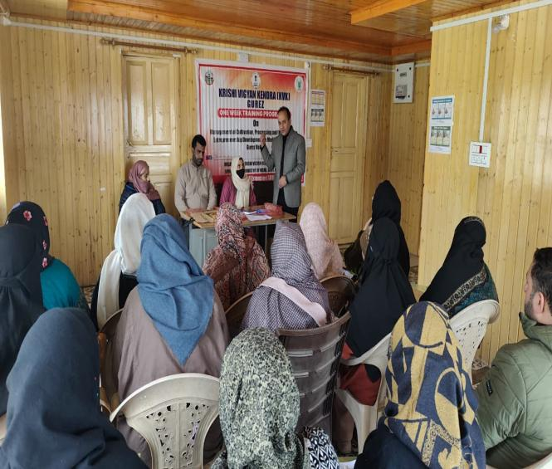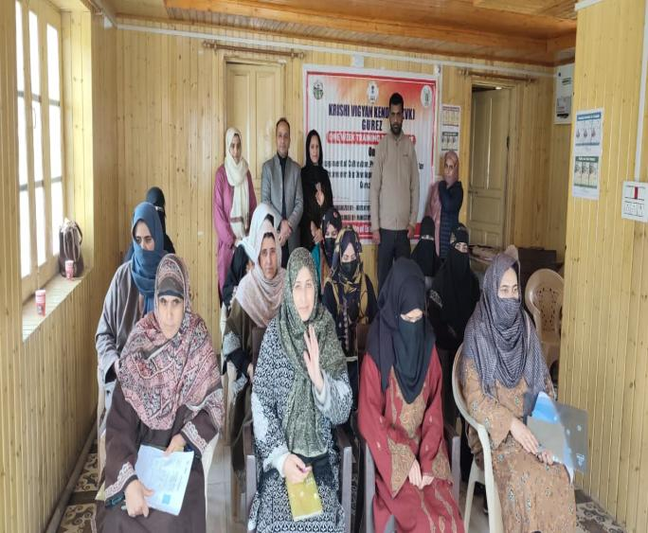
1 Week MSME Training Programme
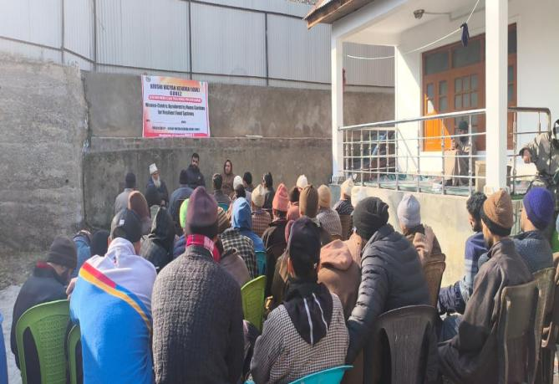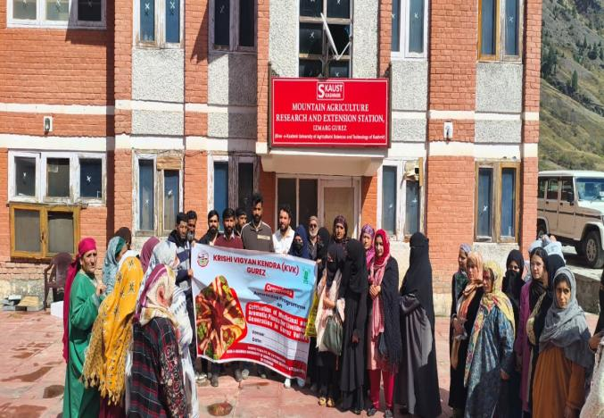
1 Day MSME Training Programme Awareness Programme on MAPs
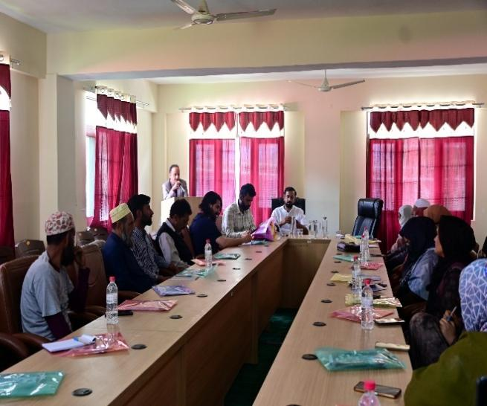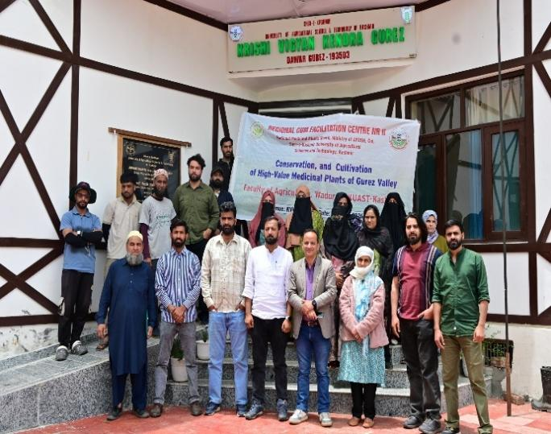
Collaborative Programme with RCFC NR-II

High Value Medicinal and Aromatic Plants of Gurez Valley
S. No. | Species | Photograph
1 | Artemisia maritima Linn.  Local Name: Noorie  Family: Asteraceae  Habit: Herb  Altitudinal range (amsl): 2200–3500 m  Traditional use: The dried herb is prepared as a decoction and consumed to eliminate intestinal parasitic worms. It remains a commonly used traditional remedy in the valley. | 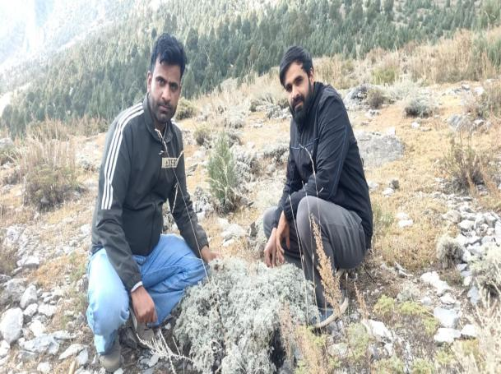
2 | Artemisia absinthium Linn.  Local Name: Chhuma-Jom  Family: Asteraceae  Habit: Herb  Altitudinal range (amsl): 2000-3000 m  Traditional use: The dried herb is powdered and administered in traditional medicine for the treatment of epilepsy and fever. The plant is also known for its aromatic and medicinal properties. | 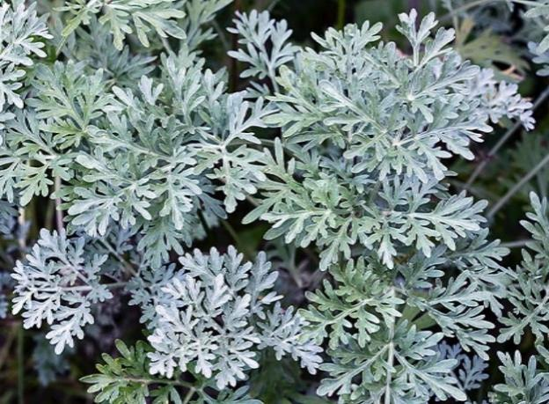
3 | Angelica glauca Edgew  Local Name: Chora  Family: Apiaceae)  Habit: Herb  Altitudinal range (amsl): 2500-3800 m  Traditional use: Angelica glauca is an important medicinal herb of Gurez Valley. The local inhabitants prepare a decoction of the whole plant, which is traditionally used as a cardiac stimulant. It is also employed in indigenous medicine for the treatment of mental disorders and general weakness. | 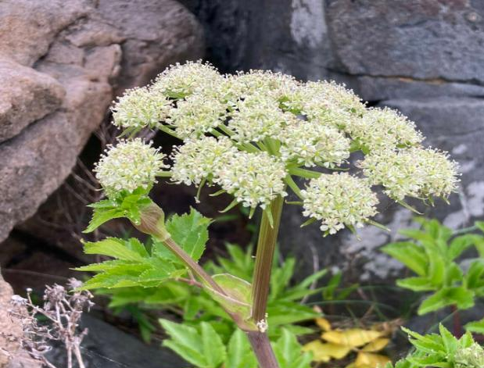
4 | Arctium lappa Linn.  Local Name: Cheerkachh  Family: Asteraceae  Habit: Herb  Altitudinal range (amsl): 2000–3200 m  Traditional use: The powdered roots of Arctium lappa are traditionally used as a diuretic. The species is valued for promoting urine flow and helping alleviate urinary complaints. | 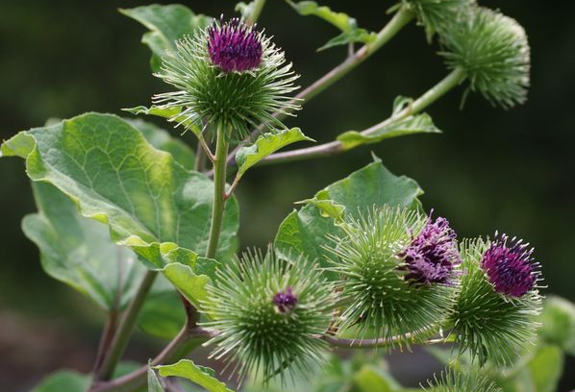
5 | Atropa acuminata Royle  Local Name: Belladona  Family: Solanaceae  Habit: Herb  Altitudinal range (amsl): 2000-3600 m  Traditional use: The roots and leaves of Atropa acuminata are used as a sedative, analgesic, and diuretic. Due to its potent medicinal properties, it occupies an important place in local ethnomedicine. | 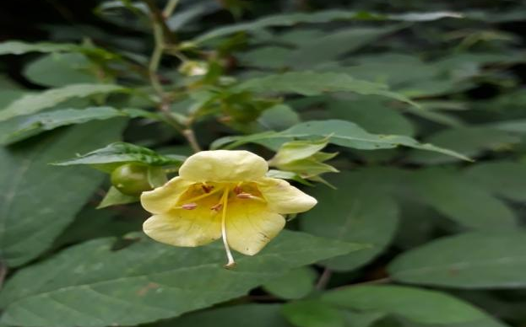
6 | Aconitum heterophyllum Wall. ex Royle  Local Name: Patees  Family: Ranunculaceae  Habit: Herb  Altitudinal range (amsl): 2500-4000 m  Traditional use: It is one of the most important medicinal herbs of the Himalayas. The powdered roots are traditionally used in small doses for the treatment of diarrhoea, dysentery, fever, and enlargement of the spleen. Due to its high market value and excessive collection from the wild, the species has become rare in many parts of its natural range. | 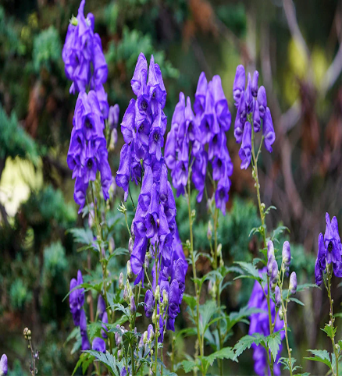
7 | Angelica archangelica var. himalaica  Local Name: Chora  Family: Apiaceae  Habit: Herb  Altitudinal range (amsl): 2400–3800 m  Traditional use: A decoction of the roots and fruits is used as an expectorant and is administered for respiratory ailments such as cough, cold, and chest congestion. | 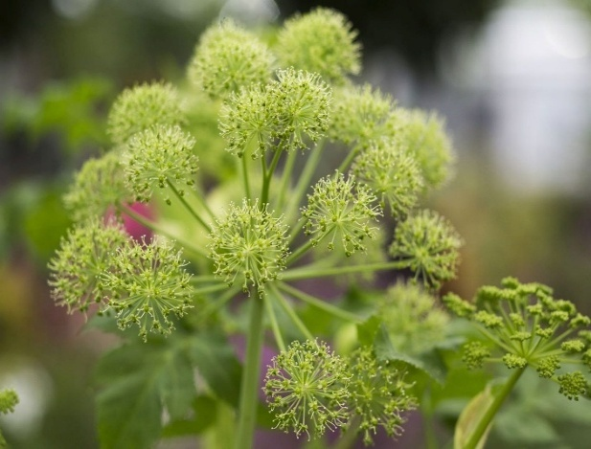
8 | Arnebia benthamii (Wall. ex G. Don) Johnston  Local Name: Kahzaban  Family: Boraginaceae  Habit: Herb  Altitudinal range (amsl): 3000-4500 m  Traditional use: The roots yield a red dye and are used in traditional medicine for wound healing, skin diseases, burns, and inflammation. | 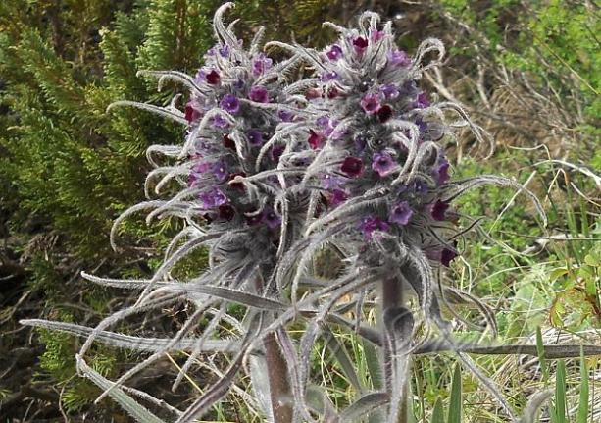
9 | Bergenia ciliata Sternb.  Local Name: Pahend/Korasadun  Family: Saxifragaceae  Habit: Herb  Altitudinal range (amsl): 2000–3000 m  Traditional use: The rhizome powder is used as a tonic and is especially renowned for treating kidney and bladder stones. It is among the most widely utilized medicinal plants of the Himalayan region. | 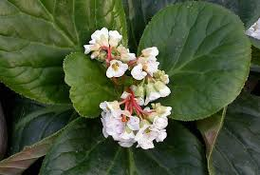
10 | Betula utilis D. Don  Local Name: Burz  Family: Betulaceae  Habit: Tree  Altitudinal range (amsl): 2800–4000 m  Traditional use: The bark infusion of Himalayan Birch is traditionally used as an antiseptic for treating infections and promoting wound healing. | 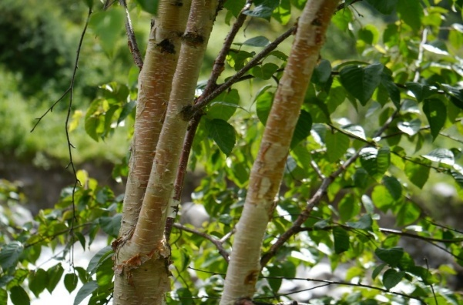
11 | Bunium persicum (Boiss.) Fedtsch.  Local Name: Hayaw  Family: Apiaceae  Habit: Herb  Altitudinal range (amsl): 1800–3500 m  Traditional use: The seeds are highly valued for their medicinal and culinary importance. A decoction of the seeds is used to treat digestive disorders and enhance milk production in lactating mothers. | 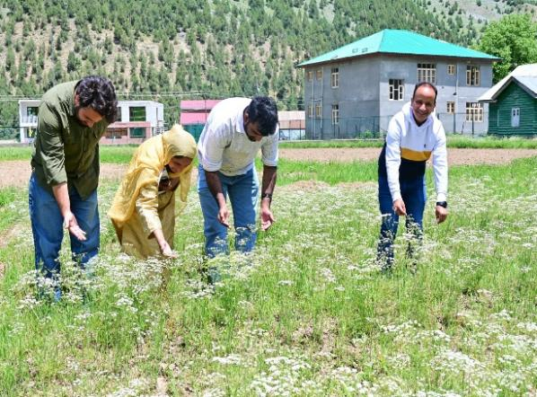
12 | Bupleurum falcatum Linn.  Family: Apiaceae  Habit: Herb  Altitudinal range (amsl): 2000–3500 m  Traditional use: A decoction prepared from the whole plant is traditionally used in the treatment of liver disorders and digestive ailments. | 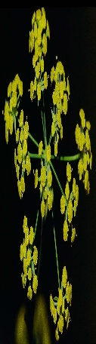
13 | Berberis lycium Royle  Local Name: Kawdach  Family: Berberidaceae  Habit: Shrub  Altitudinal range (amsl): 1500–3000 m  Traditional use: It is one of the most widely utilized medicinal shrubs in the western Himalaya. | 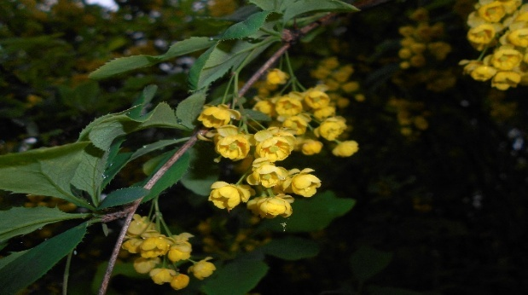
14 | Cichorium intybus Linn.  Local Name: Kasini  Family: Asteraceae  Habit: Herb  Altitudinal range (amsl): 1500–3000 m  Traditional use: Powdered roots are used in traditional medicine to treat liver disorders, spleen enlargement, and menstrual complaints. | 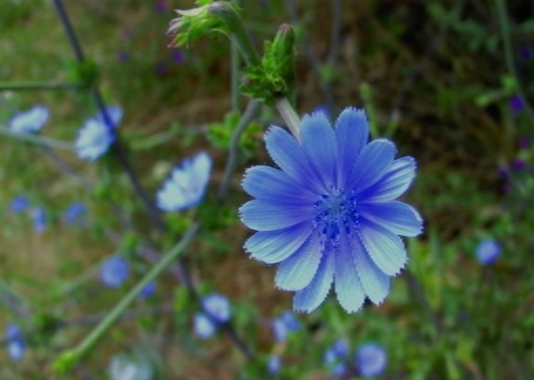
15 | Codonopsis ovata Benth.  Family: Campanulaceae  Habit: Herb  Altitudinal range (amsl): 2500–3800 m  Traditional use: The root powder is applied externally on wounds and ulcers to facilitate healing and prevent infection. | 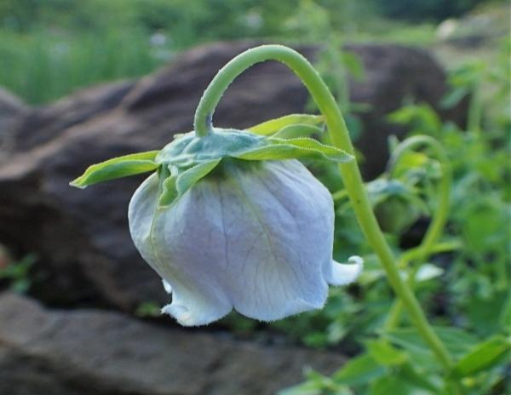
16 | Corydalis ramosa Wall.  Local Name: Ralkul  Family: Papaveraceae  Habit: Herb  Altitudinal range (amsl): 2500-4000 m  Traditional use: A cold extract of the herb is applied externally for the treatment of various eye diseases. | 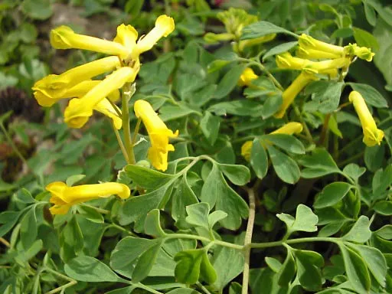
17 | Cuscuta reflexa Roxb.  Local Name: Janeo-bal  Family: Convolvulaceae  Habit: Climber  Altitudinal range (amsl): 1500–3000 m  Traditional use: A cold aqueous extract of the plant is traditionally used for washing wounds and preventing infection. | 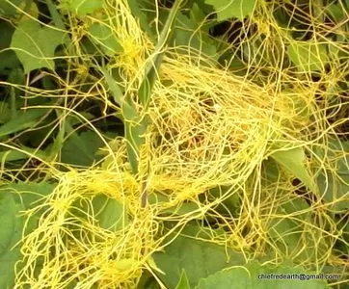
18 | Crataegus songarica K. Koch  Local Name: Ring Kul  Family: Rosaceae  Habit: Shrub  Altitudinal range (amsl): 2000–3200 m  Traditional use: The fruits are consumed fresh and are considered beneficial for cardiovascular health. Traditional communities also use the fruits for digestive ailments and general well-being. | 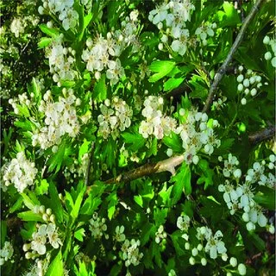
19 | Dactylorhiza hatagirea (D. Don)  Local Name: Salam Panja  Family: Orchidaceae  Habit: Herb  Altitudinal range (amsl): 2800–4200 m  Traditional use: The tubers are regarded as a powerful tonic and aphrodisiac. They are traditionally used to improve strength, vitality, and reproductive health. Due to overharvesting, the species is considered threatened throughout the Himalayas. | 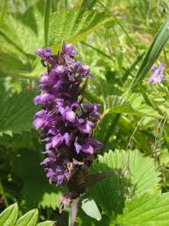
20 | Epipactis latifolia All.  Local Name: Ikchha-neuli  Family: (Orchidaceae  Habit: Herb  Altitudinal range (amsl): 2000–3500 m  Traditional use: A decoction of the whole plant is consumed for relief from heart pain and related ailments. | 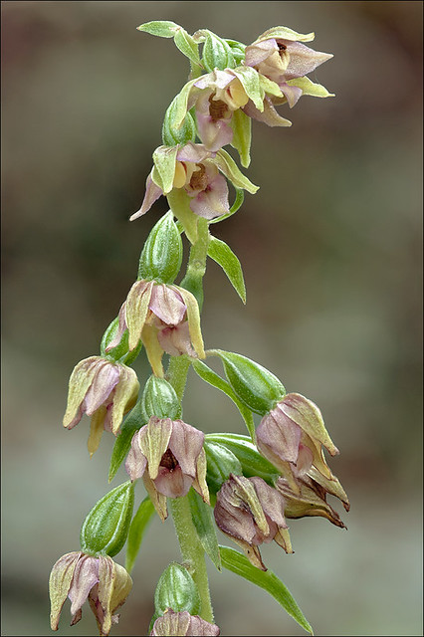
21 | Euphorbia pilosa Linn.  Local Name: Burse Kachh  Family: Euphorbiaceae  Habit: Herb  Altitudinal range (amsl): 2000–3500 m  Traditional use: The whole plant extract is traditionally used for the treatment of fistular sores and skin infections. | 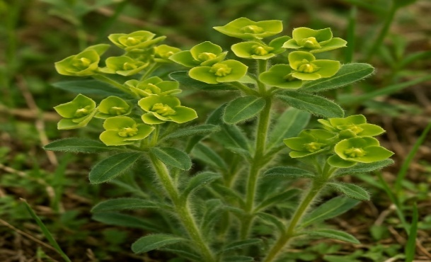
22 | Euphrasia officinalis Linn.  Local Name: Pushi-kachh  Family: Scrophulariaceae  Habit: Herb  Altitudinal range (amsl): 2000–4000 m  Traditional use: A decoction prepared from the plant is taken to cure jaundice and improve liver function. | 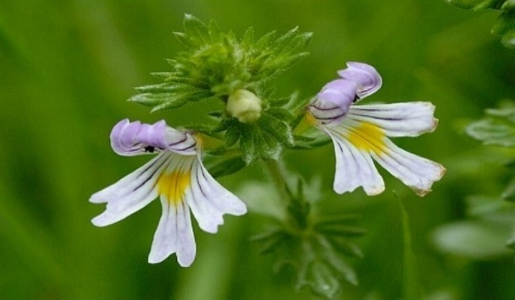
23 | Fritillaria cirrhosa Hook. f.  Local Name: Sheetkar  Family: Liliaceae  Habit: Herb  Altitudinal range (amsl): 2800-4200 m  Traditional use: The powdered herb is highly valued for treating tuberculosis, broncho-asthma, and chronic respiratory ailments. | 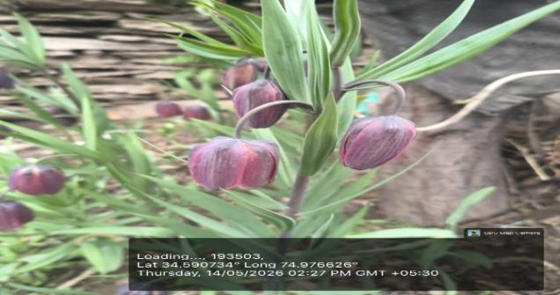
24 | Heracleum candicans Wall.  Local Name: Churu/Mirkul  Family: Apiaceae  Habit: Herb  Altitudinal range (amsl): 2500-4000 m  Traditional use: The powdered fruits are used as an aphrodisiac and general health tonic. | 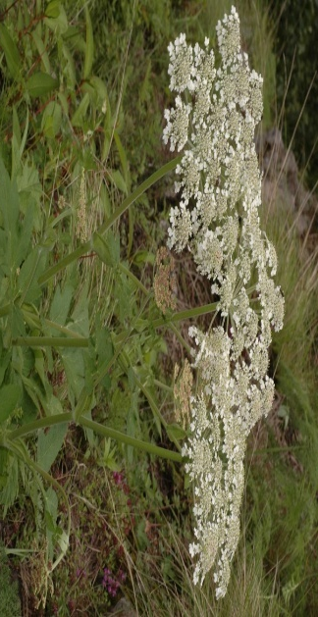
25 | Hippophae rhamnoides Linn.  Local name: Poppo  Family: Elaeagnaceae  Habit: Shrub  Altitudinal range (amsl): 2000-4000 m  Traditional use: Fruit jelly prepared from Sea Buckthorn is consumed for hepatic enlargement and general health improvement | 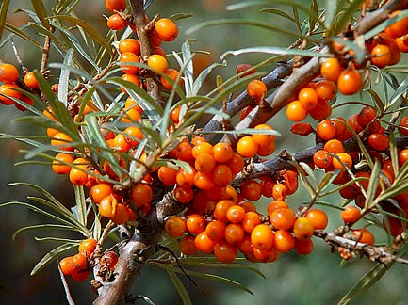
26 | Hyoscyamus niger Linn.  Local Name: Bazarbang  Family: Solanaceae  Habit: Herb  Altitudinal range (amsl): 2000–3800 m  Traditional use: The powdered herb is traditionally used to treat asthma, whooping cough, and respiratory discomfort. | 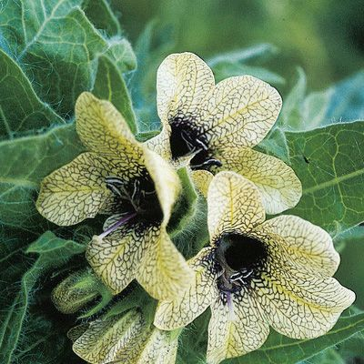
27 | Inula racemosa Hook. f.  Local Name: Poshkar  Family: Asteraceae  Habit: Herb  Altitudinal range (amsl): 2000-4000 m  Traditional use: Root powder or decoction is widely used in the treatment of asthma, bronchitis, and other respiratory disorders. | 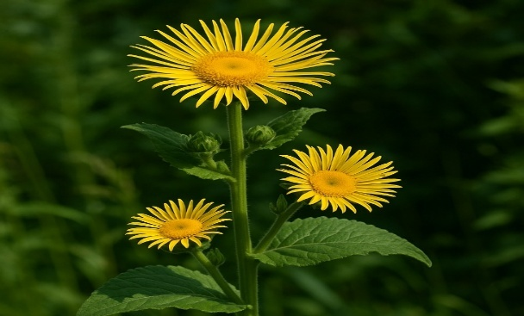
28 | Inula royleana DC.  Local Name: Punara/Poshkar  Family: Asteraceae  Habit: Herb  Altitudinal range (amsl): 2000–3500 m  Traditional use: The root decoction serves as an expectorant, while the herb paste is applied externally to treat skin diseases. | 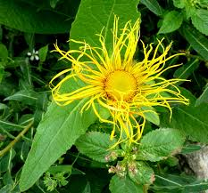
29 | Juglans regia Linn.  Local Name: Dun  Family: Juglandaceae  Habit: Tree  Altitudinal range (amsl): 1500–3300 m  Traditional use: The bark and green fruit pericarp are used for strengthening gums, cleaning teeth, and maintaining oral hygiene. | 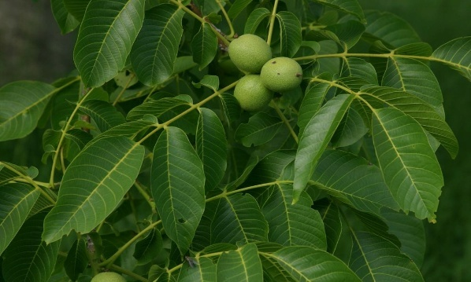
30 | Jurinea macrocephala Benth.  Local Name: Dhup  Family: Asteraceae  Habit: Herb  Altitudinal range (amsl): 3000-4500 m  Traditional use: The roots of Jurinea macrocephala are used in traditional medicine for relieving colic pain. A decoction prepared from the roots is administered to alleviate abdominal discomfort and digestive disorders. | 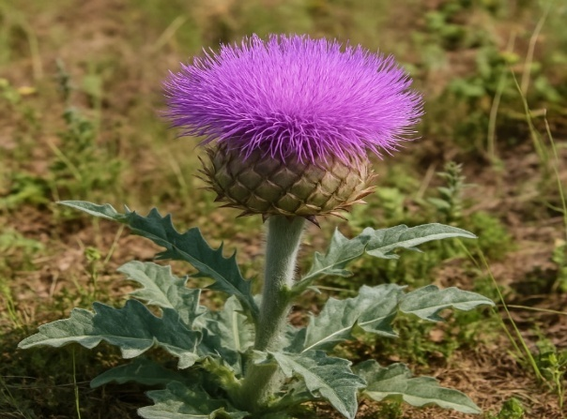
31 | Lavatera kashmiriana Camb.  Local Name: Reshma Khatmi  Family: Malvaceae  Habit: Herb  Altitudinal range (amsl): 2000–3500 m  Traditional use: The roots are traditionally used for the treatment of rheumatic pain and inflammation. The species is valued by local communities for its analgesic properties. | 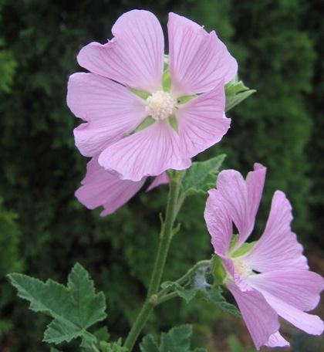
32 | Macrotomia benthamii DC.  Local Name: Jogpasha  Family: Boraginaceae  Habit: Herb  Altitudinal range (amsl): 2500-4000 m  Traditional use: A decoction prepared from the roots is used as a febrifuge to reduce fever. It is also employed in the treatment of ulcers and related ailments. | 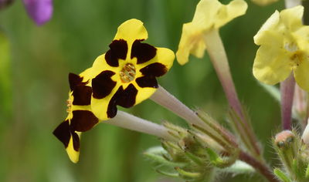
33 | Malva verticillata Linn.  Local Name: Pudinakachh  Family: Malvaceae  Habit: Herb  Altitudinal range (amsl): 1800–3000 m  Traditional use: A decoction of the leaves is recommended during pregnancy and is believed to promote maternal health and well-being. | 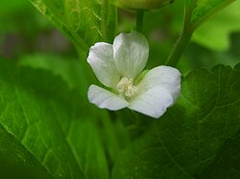
34 | Mentha arvensis Linn.  Local Name: Pudinakachh  Family: Lamiaceae  Habit: Herb  Altitudinal range (amsl): 1500–3500 m  Traditional use: The dried leaves are boiled to prepare a decoction that is used as a carminative. It helps relieve indigestion, flatulence, and abdominal discomfort | 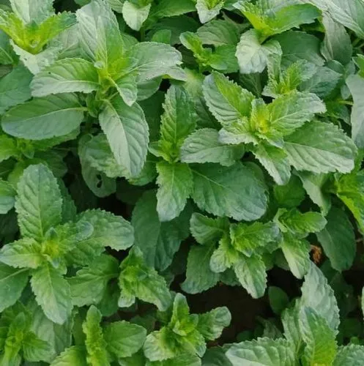
35 | Mentha longifolia (L.) Huds.  Local Name: Pudinakachh  Family: Lamiaceae  Habit: Herb  Altitudinal range (amsl): 1500–3500 m  Traditional use:Like Mentha arvensis, the dried leaves are used as a carminative and digestive aid. The aromatic herb is commonly consumed in herbal preparations. | 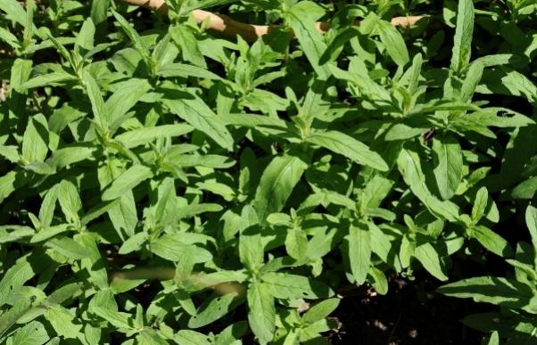
36 | Onosma hispidum Wall. ex DC.  Local Name: Rattanjot  Family: Boraginaceae  Habit: Herb  Altitudinal range (amsl): 2000-4000 m  Traditional use: The roots are used for the treatment of ulcers and urinary stone disorders. Traditional healers often combine the roots with Bergenia species and Rubia cordifolia for breaking kidney and bladder stones. | 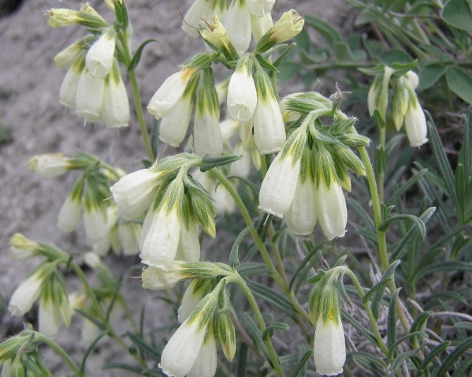
37 | Orchis latifolia Linn.  Local Name: Nar-Mada  Family: Orchidaceae  Habit: Herb  Altitudinal range (amsl): 2000-3800 m  Traditional use: The powdered tuberous roots are mixed with milk and consumed as an aphrodisiac and restorative tonic. | 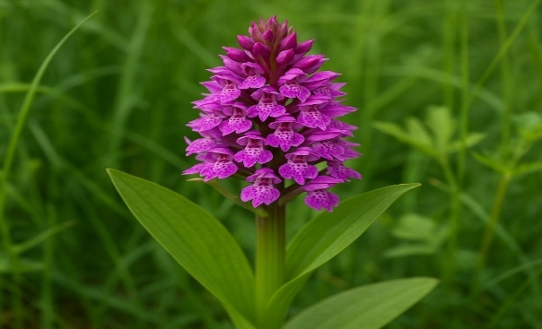
38 | Origanum vulgare Linn.  Local Name: Marzanjosh  Family: Lamiaceae  Habit: Herb  Altitudinal range (amsl): 1800–3500 m  Traditional use: A warm decoction of the herb is traditionally administered to treat menstrual suppression and related gynecological disorders. | 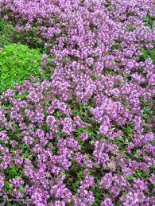
39 | Prunella vulgaris Linn.  Local Name: Kal-veoth  Family: Lamiaceae  Habit: Herb  Altitudinal range (amsl): 1800–3500 m  Traditional use: Fresh plant juice is applied externally for the treatment of piles. A decoction of the plant is also consumed to reduce fever and as an expectorant in respiratory ailments. | 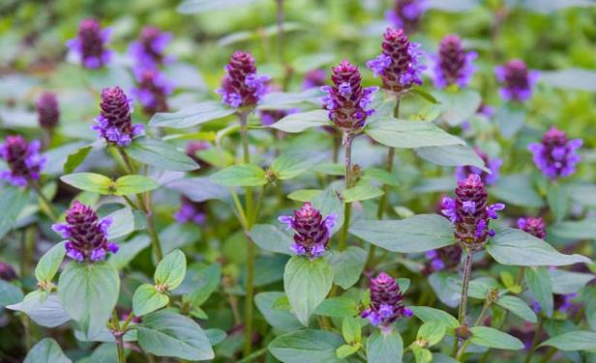
40 | Pedicularis pectinata Wall.  Local Name: Khara  Family: Scrophulariaceae  Habit: Herb  Altitudinal range (amsl): 2500–4200 m  Traditional use: The powdered herb is used as a diuretic and is believed to increase urine flow and support urinary health. | 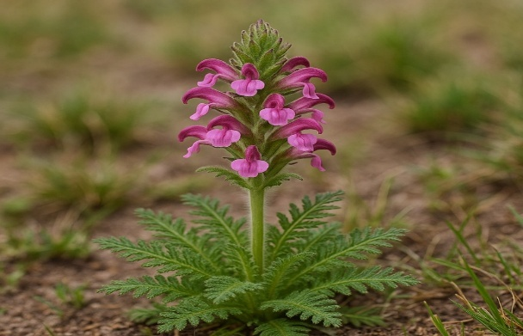
41 | Picrorhiza kurroa Royle ex Benth.  Local Name: Kutki  Family: Scrophulariaceae  Habit: Herb  Altitudinal range (amsl): 3000-4500 m  Traditional use: The powdered roots are extensively used in indigenous medicine for liver disorders, particularly jaundice. This species is one of the most valued medicinal plants of the Himalayan region. | 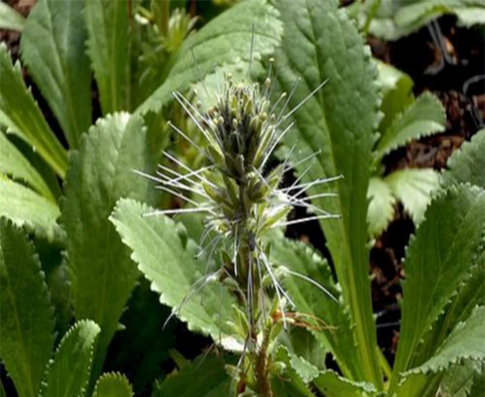
42 | Pimpinella diversifolia DC.  Local Name: Hyo-kachh  Family: Apiaceae  Habit: Herb  Altitudinal range (amsl): 2000–3500 m  Traditional use: A hot aqueous extract of the plant is taken as a carminative to improve digestion and relieve gastric discomfort. | 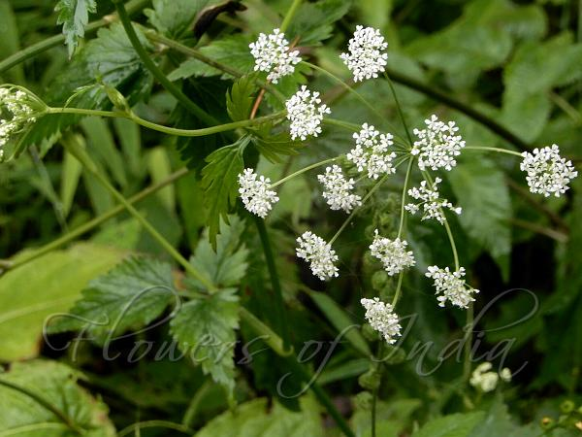
43 | Plantago lanceolata Linn.  Local Name: Phatal Kachh  Family: Plantaginaceae  Habit: Herb  Altitudinal range (amsl): 1500–3500 m  Traditional use: The seeds are consumed with milk as a purgative and are traditionally used to regulate bowel movements. | 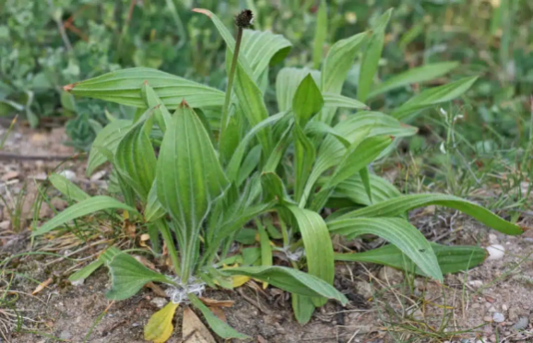
44 | Podophyllum hexandrum Royle  Local Name: Chhamadeh/Wanwagun  Family: Berberidaceae  Habit: Herb  Altitudinal range (amsl): 2500-4200 m  Traditional use: The powdered roots are used in the treatment of hepatic enlargement and other liver-related disorders. It is an important high-value medicinal species of the Himalayas. | 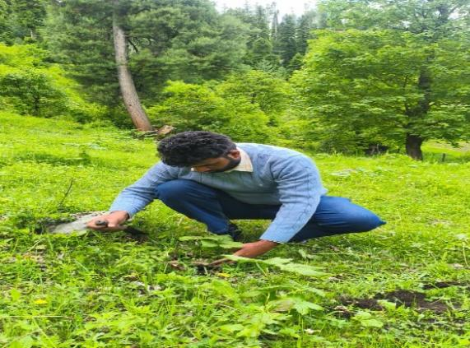
45 | Polygonum viviparum Linn.  Local Name: Churkee  Family: Polygonaceae  Habit: Herb  Altitudinal range (amsl): 2500-4500 m  Traditional use: The roots are used to treat diarrhoea and dysentery. A paste of the roots is also applied externally to stop bleeding and promote healing of ulcers. | 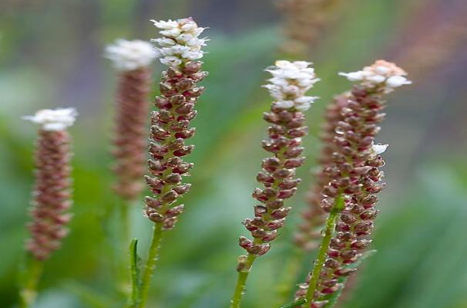
46 | Rubia cordifolia Linn.  Local Name: Manjithi  Family: Rubiaceae  Habit: Herb  Altitudinal range (amsl): 1500-3500 m  Traditional use: The roots are traditionally used for the treatment of stomach ache and digestive disorders. The plant is also valued for its medicinal and dye-producing properties. | 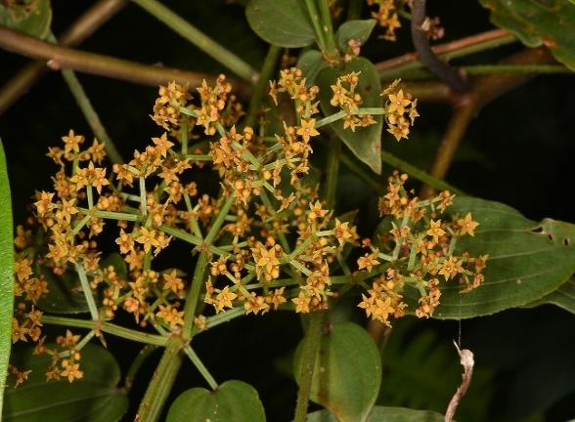
47 | Rosa webbiana Wall. ex Royle  Local name: Gulab  Family: Rosaceae  Habit: Shrub  Altitudinal range (amsl): 2000-4000 m  Traditional use: The fruits (rose hips) are rich in vitamin C and are traditionally used to prepare syrups and remedies for cold, cough, and general weakness. | 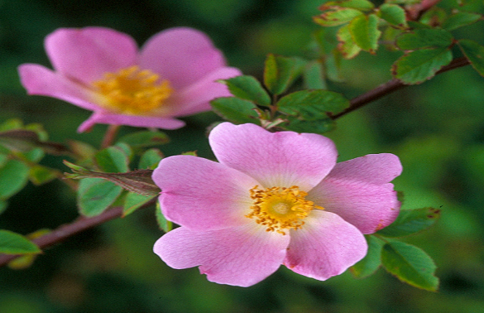
48 | Rheum webbianum Royle  Local Name: Pambchalan  Family: Polygonaceae  Habit: Herb  Altitudinal range (amsl): 3000-4500 m  Traditional use: The roots are used as a laxative and stomachic. Traditional healers also prescribe preparations of the plant for digestive disorders and liver complaints. It is among the important medicinal rhubarbs of the western Himalaya. | 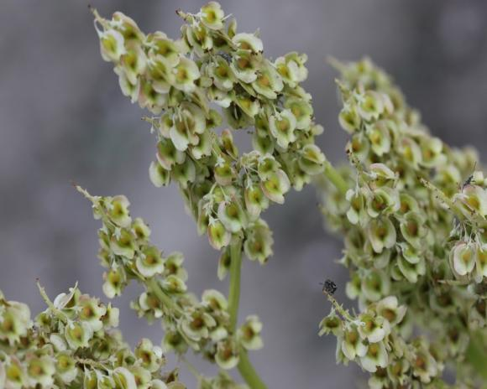
49 | Rheum australe D. Don  Local Name: Pambchalan  Family: Polygonaceae  Habit: Herb  Altitudinal range (amsl): 2800-4500 m  Traditional use: The roots possess purgative properties and are used in the treatment of constipation, stomach disorders, and liver ailments. The species is highly valued in traditional medicine. | 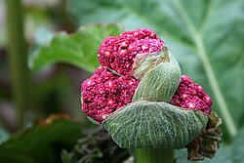
50 | Saussurea costus (Falc.) Lipsc  Local Name: Kuth  Family: Asteraceae  Habit: Herb  Altitudinal range (amsl): 2500-4000 m  Traditional use: The root paste is applied externally to relieve rheumatism, joint pain, and muscular inflammation. Historically, this species was one of the most valuable medicinal plants traded from Kashmir. | 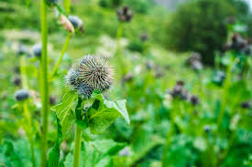
51 | Taraxacum officinale Weber ex Wiggers  Local Name: Hand  Family: Asteraceae  Habit: Herb  Altitudinal range (amsl): 1800-4000 m  Traditional use: A decoction of the roots is used as a hepatic stimulant and is especially valued in the treatment of jaundice. The cooked leaves are traditionally given to pregnant women at the time of delivery to facilitate smooth childbirth. | 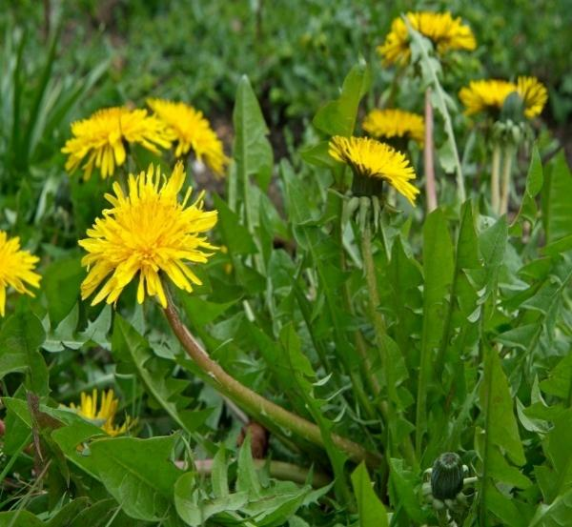
52 | Taxus baccata Linn.  Local Name: Postul  Famiy: Taxaceae  Habit: Herb  Altitudinal range (amsl): 2000-3500 m  Traditional use: The bark is prepared as a decoction or herbal tea and used for the treatment of asthma, bronchitis, and respiratory ailments. The species is also recognized globally for its medicinal significance. | 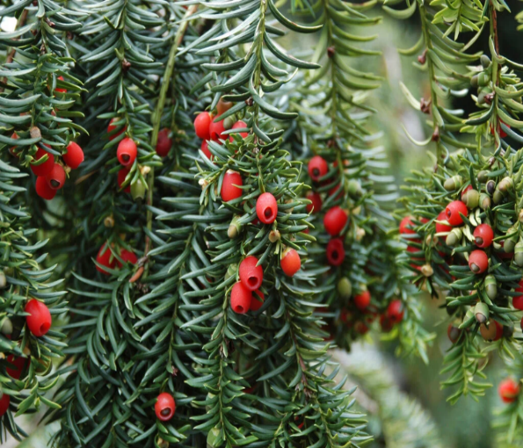
53 | Thymus linearis Linn.  Local Name: Javen  Family: Lamiaceae  Habit: Herb  Altitudinal range (amsl): 2000-4000 m  Traditional use: The whole herb is used as a decoction to treat flatulence, indigestion, and menstrual disorders. Its aromatic nature also makes it a popular herbal remedy. | 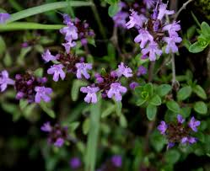
54 | Trifolium pratense Linn.  Local Name: Lalchopati  Family: Fabaceae  Habit: Herb  Altitudinal range (amsl): 1800-3500 m  Traditional use: The dried herb is consumed as a herbal tea and used as an expectorant in respiratory ailments such as cough and congestion. | 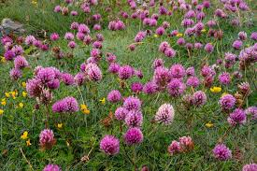
55 | Valeriana hardwickii Wall.  Local Name: Mushk Bala  Family: Valerianaceae  Habit: Herb  Altitudinal range (amsl): 2000-4000 m  Traditional use: The powdered roots are traditionally inhaled to treat hysteria, epilepsy, and nervous disorders. The species is well known for its calming and sedative properties. | 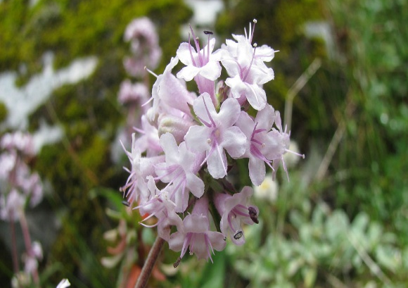
56 | Viola sylvatica Fries  Local Name: Banafsha  Family: Violaceae  Habit: Herb  Altitudinal range (amsl): 1800-3500 m  Traditional use: The dried plant is boiled to prepare a medicinal tea used for treating cough, cold, and throat ailments. It remains one of the most commonly used herbal remedies in the region. | 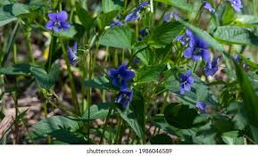
57 | Viscum odorata Linn.  Local Name: Banada  Family: Viscaceae  Habit: Shrub  Altitudinal range (amsl): 1800-3500 m  Traditional use: A warm paste prepared from the plant is applied externally to relieve rheumatism, joint pain, and muscular inflammation. The species continues to be used in traditional folk medicine across the valley. | 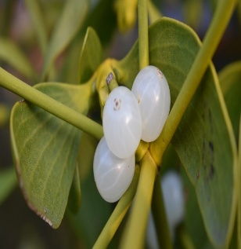

Way Forward
The rich medicinal and aromatic plant diversity of Gurez Valley represents an invaluable ecological, cultural, and economic resource that warrants urgent conservation and sustainable utilization. Future efforts will focus on strengthening in situ and ex situ conservation of threatened species, expanding the MAPs Germplasm Bank, and promoting scientific cultivation of high-value medicinal plants to reduce pressure on wild populations. Systematic documentation and validation of indigenous traditional knowledge, coupled with awareness programmes and capacity building for farmers and rural youth, will help preserve this unique heritage while creating sustainable livelihood opportunities. Collaborative research involving local communities, research institutions, government agencies, and conservation organizations will be encouraged to develop evidence-based conservation strategies, value-addition technologies, and market linkages. Through an integrated approach that combines traditional wisdom with modern science, Gurez Valley can emerge as a model landscape for biodiversity conservation, herbal healthcare, and sustainable rural development in the Himalayan region.

Sher-e-Kashmir University of Agricultural Sciences and Technology of Kashmir
Editors:
Dr. Jauhar Rafeeq
SMS (Agroforesty)

Dr. Hilal Ahmad Malik
Head KVK Gurez

Dr. Shahida Altaf
SMS (Plant protection)

Mr. Manzoor Ahmad Khatana
Programme Assistant (lab)

Mr. Ravi Kumar
(Farm Manager)

Mr. Tanzeer Hussain Khan
Programme Assistant (Computers)

Printing
Mr. Suhail Subhan

Krishi Vigyan Kendra Gurez

Directorate o Extension

Sher-e-Kashmir University of Agricultural Sciences and Technology of Kashmir
******

