EXTENSION PUBLICATION NO. AU/DEx/497-Bl/07/2026

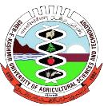
KRISHI VIGYAN KENDRA (KVK)
GUREZ

Revival of heritage crop Buckwheat:

Initiative & the way forward

Chief Patron
Prof. Nazir Ahmad Ganai
Hon’ble Vice-Chancellor

Patron
Prof Raihna Habib Kanth
Director Extension

Directorate of Extension
Sher-e-Kashmir University of Agricultural Sciences &Technology of Kashmir
Gurez: overall scenario
Gurez Valley is a high-altitude Himalayan valley situated at an elevation of approximately 8,000–11,000 feet above sea level in the northern part of Kashmir. The valley lies along the Kishanganga river and is characterized by rugged mountain terrain, snow-covered peaks, dense coniferous forests, and extensive alpine pastures. It experiences a temperate to sub-alpine climate, with prolonged winters marked by heavy snowfall and a short growing season extending from May to September, conditions that strongly influence its agricultural practices and biodiversity. The southeastern boundary is defined by the Pir Panjal Range, which separates Gurez from the Tulail Valley and enhances the region's scenic and recreational appeal. Located beyond the Razdan Pass and adjoining the Line of Control (LoC) , the valley holds strategic importance while also supporting diverse agro-ecological systems. Its unique combination of climatic conditions, natural resources, and rich biodiversity offers significant opportunities for sustainable agriculture, horticulture, eco-tourism, and conservation-oriented development. Its geographical isolation, rugged terrain, and limited irrigation have resulted in a subsistence-based, predominantly rainfed farming system. The total cultivable area of Gurez Valley is estimated at 732.54 hectare. Potato is the predominant crop, covering 243.64 hectare (33%) of the total cultivable area followed by Rajmash cultivated over 169.86 hectare (23%), and wheat, occupying 164.73 hectare (22%). Maize is grown on 85.60 hectare (12%), while oats cover 44.02 hectare (6%). Vegetables occupy the smallest share, with 24.69 hectare (3%) of the total cultivable area while buckwheat and millets occupy about 3% of the total cultivable area. All these crops coupled with livestock rearing, constitute the primary source of livelihood and food security for the local population
Buckwheat – An Insight
Buckwheat (Fagopyrum esculentum), locally known as “Barawh,” occupies a special place in the traditional agricultural system of Gurez Valley. Cultivated for centuries, it is one of the most important pseudo-cereal crops of the region, serving both a staple food and a valuable source of livestock and poultry feed. The unique high-altitude environment, cool growing season, and fertile soils of Gurez provide favourable conditions for its cultivation. Owing to its short growth duration of 70–90 days and its ability to thrive on relatively poor soils with minimal agricultural inputs, buckwheat has become an indispensable component of the valley's subsistence farming system.
Traditionally, buckwheat is cultivated on terraced mountain slopes and narrow valley floors of Gurez Valley while the sowing practices flinches just after snow starts melting usually during June and harvested before the onset of frost in late August or early September enabling farmers to obtain reliable yields within the short growing season. Though Buckwheat is believed to be a wonder crops with tremendous scope in pharmacological, industrial importance m however at Gurez the grains are milled into flour and used for preparing traditional foods such as roti, pancakes, porridge, and other local delicacies, while the straw and leaves serve as nutritious livestock fodder. Owing to its adaptability to high-altitude conditions and multiple uses, buckwheat remains an integral component of the valley’s subsistence farming system.

Significance of buckwheat: A broder perspective
- Rich in high-quality protein, dietary fibre, essential minerals, vitamins, antioxidants, and bioactive compounds which possess antioxidant and anti-inflammatory properties. Regular consumption is associated with improved cardiovascular health, better blood sugar regulation, enhanced digestive health, and overall nutritional well-being.
- Serves as an important alternative crop in high-altitude and marginal areas where conventional cereals perform poorly. Its short growth duration (70–90 days) ensures reliable yields under adverse conditions.
- Well adapted to poor soils, low-input conditions, and short growing seasons, making it suitable for climate-resilient agriculture.
- Generally suffers from fewer insect pests and diseases, reducing pesticide use and supporting organic farming.
- Its dense canopy suppresses weeds naturally, reducing weed competition and labour requirements.
- Produces abundant flowers that attract honeybees and other pollinators, promoting pollination and biodiversity.
- Leaves, stems, and crop residues provide nutritious fodder for livestock.
- Contributes to food security, nutrition, income generation, and sustainable agricultural production in high-altitude regions such as Gurez Valley.
Buckwheat once a prime crop of Gurez, however declined due to following reasons
Despite its agronomic adaptability, nutritional value, and cultural importance, buckwheat cultivation has witnessed a gradual decline Gurez valley mainly due to following reasons:
- The widespread availability of subsidized cereals such as wheat and rice through public distribution system.
- Changing dietary preferences.
- Limited market opportunities and low economic returns have collectively contributed to the reduction in the area under buckwheat cultivation.
Consequently, a crop that once formed an integral part of traditional mountain farming systems has become increasingly marginalized.
Buckwheat a wonder crop of Gurez mainly due to following reasons:
- Organic and natural
- Health benefits
- Native and inherent to the place
- Resistant against insect, pest, diseases and the changing environment
- Low interventions / Skill required
- Low or even no input requirement
- Well adaptability
- Local preferences
- A potential to serve as an alternate crop
- Excellent for bee pollination & there by enhancing production trend.
- Can grow very well in the lands not otherwise considered suitable for commercial crops.

Initiatives taken by KVK Gurez for Revival and promotion of Buckwheat
Under the visionary leadership of the Vice-Chancellor, SKUAST-K, Prof. Nazir Ahmad Ganai and Director Extension, Prof. Raihana Habib Kanth , Krishi Vigyan Kendra (KVK) Gurez in collaboration with Dryland Agriculture Research Station (DARS) Srinagar (Courtesy : Tribal Sub-Plan of ACRIP on Potential Crops) has taken a series of Extension & Research initiatives starting from orientation, seed distribution, technological backstopping, capacity building programmes (CBPs) , packing and market linkages taking on board Institute of Business & Polucy Reseach (IBPR), SKUAST-Kashmir revival and promotion of buckwheat. As part of the outreach efforts, the Kendra has adopted a complete village of Dangan Bagtore Block Gurez under the ambit of Buckwheat Programme during 2025-26. Among its key initiatives is the distribution of quality seeds to tribal farmers to enhance productivity and self-reliance. By providing quality seeds, practical training, and continuous guidance, the center was enabling farmers to rediscover buckwheat as a climate-resilient, pollinator-friendly, and economically valuable crop. Today, buckwheat stands as a symbol of sustainability, biodiversity, and resilience in the high-altitude farming systems in the given village and motivation for other farmers for its wider adoption while the village of Dangan has emerged as a remarkable success story in the revitalization of traditional agriculture.

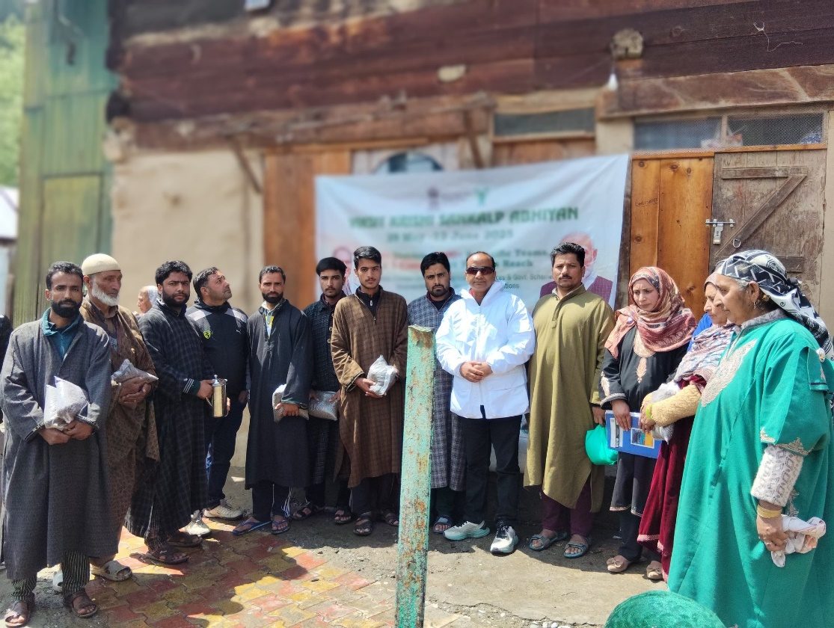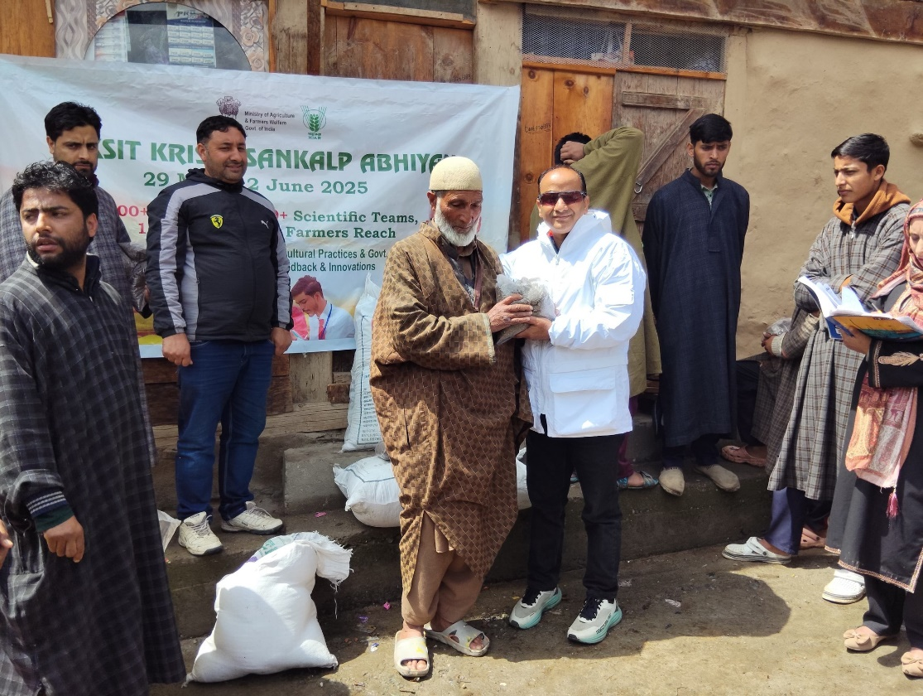
Distribution of technological input (Buckwheat seed)

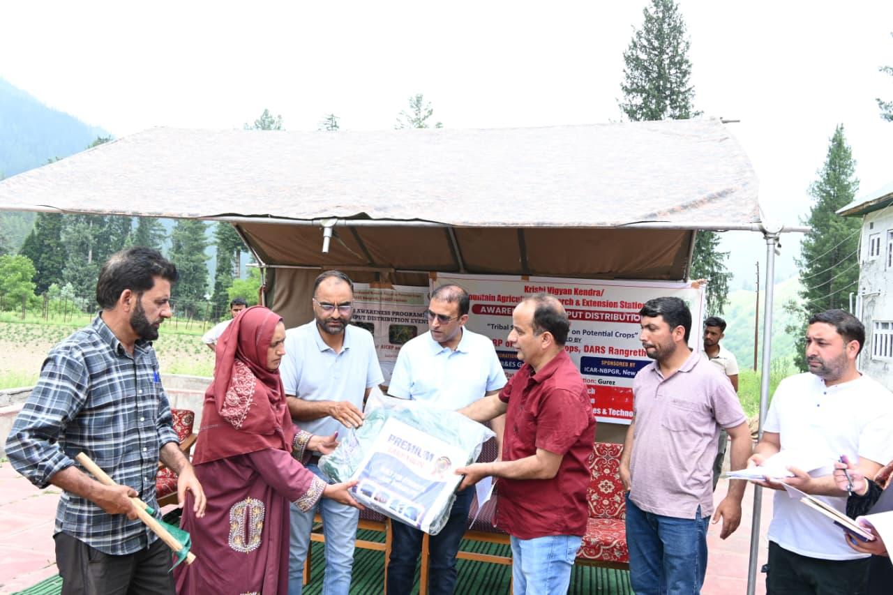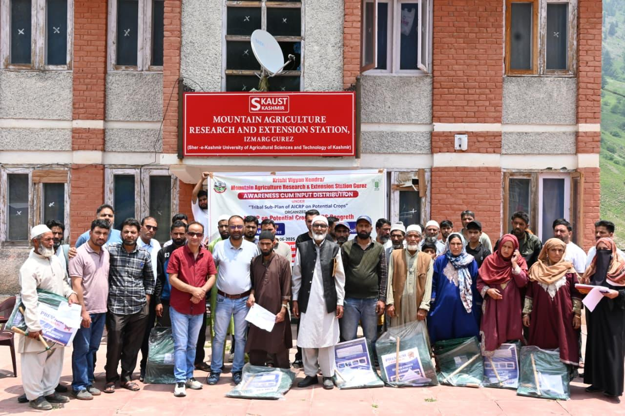
Training cum Input Distribution Programme Buckwheat seed among Farmers

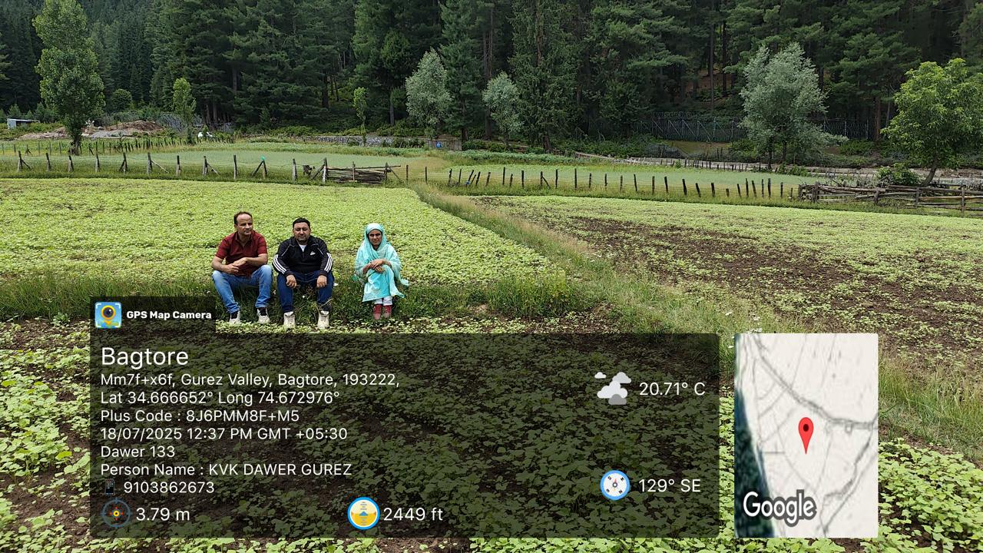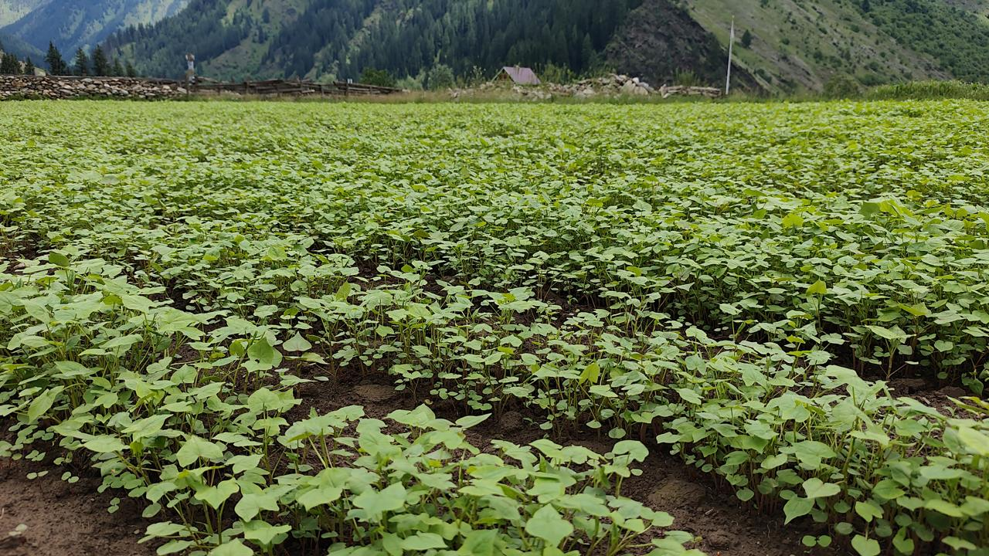
Germination Stage

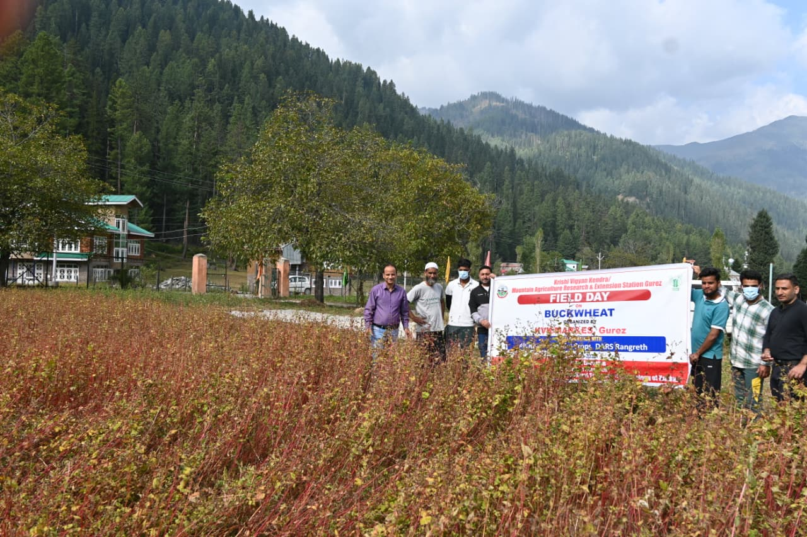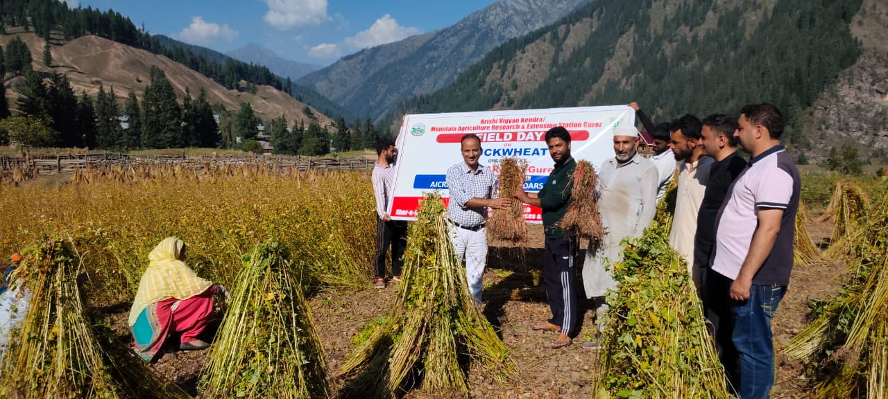
From barren to golden fields –Harnessing the hard-work

Farmers feed back
We had almost stopped growing buckwheat, but after getting quality seed and guidance from KVK Gurez, our fields are full again. The crop grows fast and helps us feed our families.
Irshad Ahmad Ahanger
The training from KVK helped us understand how to manage sowing and harvesting in short growing season. Earlier, we used to depend on outside supplies. With buckwheat cultivation returning, we have our own food and even sell surplus grain locally.
Mohammad Shafi Ahanger
Buckwheat is not just a crop for us—it’s part of our tradition. The revival has brought pride back to our community.
Mr. Qadir Ahmad Ahanger
I was given free of cost quality seeds of Buckwheat by KVK Gurez besides training and other small agriculture tools, however, today I am being offered rupees three thousand per quintal.
Shabir Ahmad Lone

Way Forward
Given the directions by the Hon’ble Vice-Chancellor and support form the Director Extension SKUAST-Kashmir, KVK Gurez is committed to strengthen the efforts for revival of heritage crops including Buckwheat. The Kendra envisages to cover more area across Gurez valley in the backdrop that KVK Gurez is well equipped with all scientific and infrastructure support and have earned a faith in the heart of farmers enriched with knowledge and skill provided through various capacity building programme and the institutional support being continuously provided by Dryland Agriculture Research station (DARS) through All India Research Coordinated Project AICRP on potential crops. The efforts are expected to provide instrumental support as alternate system of cropping, facilitate income opportunities, provide greater opportunity to climate resilient agriculture and moreover shall help in salvaging the heritage of Gurez valley.

Editors:

Dr. Hilal Ahmad Malik,
Head KVK Gurez

Dr. Shahida Altaf
Scientist (Plant protection)

Dr. Ajaz Ahmad Lone
Prof GPB , DARS Srinagar

Dr. Jauhar Rafeeq
Scientist (Agroforestry)

Mr. Manzoor Ahmad Khatana,
Programme Assistant (lab)

Mr. Ravi Kumar
(Farm Manager),

Mr. Tanzeer Hussain Khan,
Programme Assistant (Computers)

Ms. Munazah Khalil
(FCLA)

Ms. Rafiya Hassan
(FCLA)

Krishi Vigyan Kendra (KVK) Gurez
Directorate of Extension
Sher-e-Kashmir University of Agricultural Sciences & Technology of Kashmir

