EXTENSION PUBLICATION NO. AU/DEx/499-Bl/07/2026



KRISHI VIGYAN KENDRA (KVK)
GUREZ

Gurez Tulips: Nature’s Perfect Splash of Colours

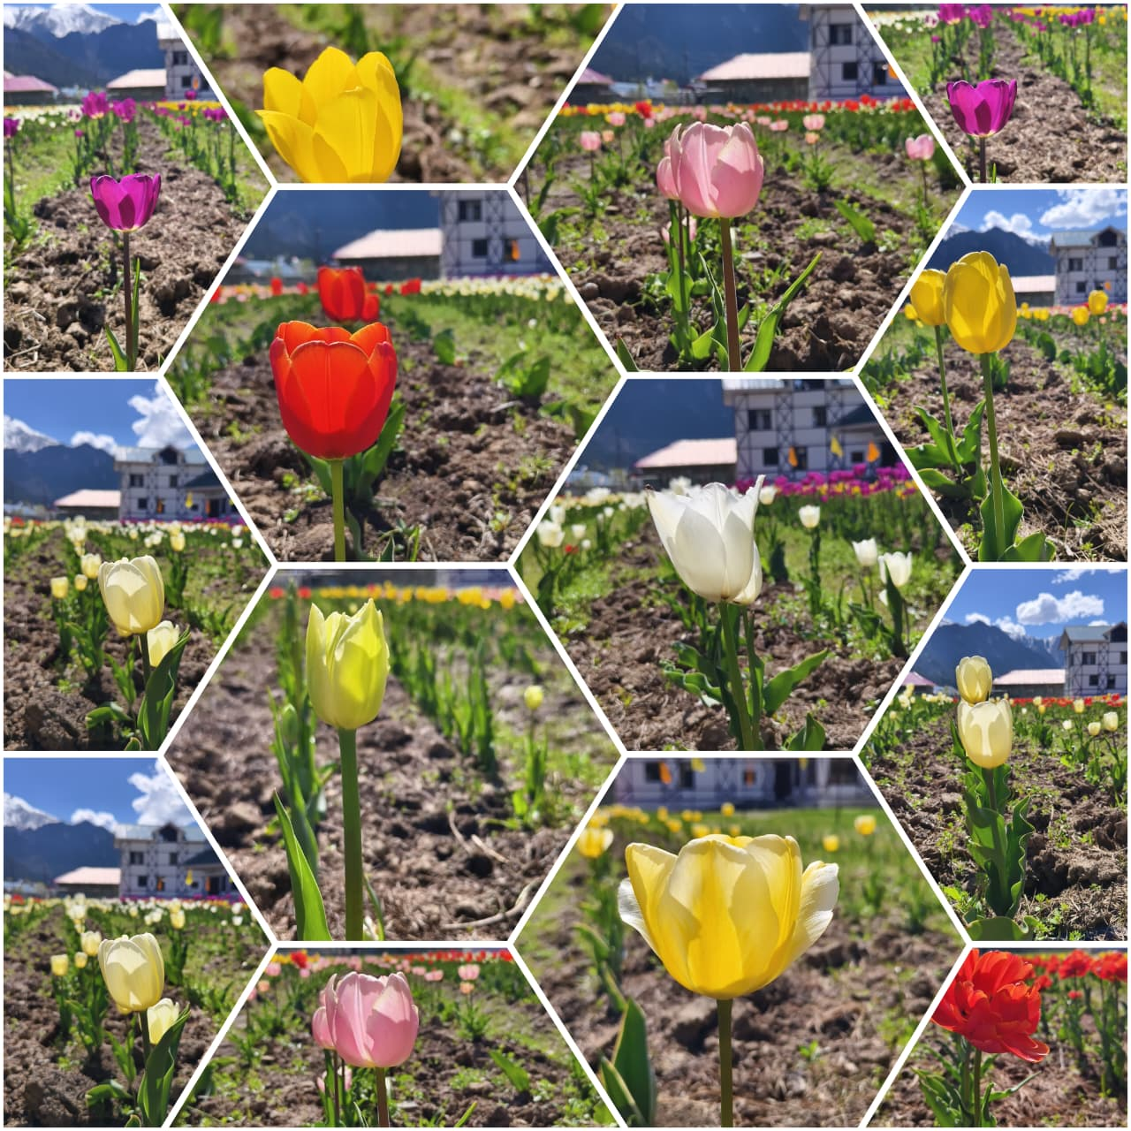
Chief Patron
Prof. Nazir Ahmad Ganai
Hon’ble Vice chancellor, SKUAST-Kashmir

Co- Patron
Prof Raihana Habib Kanth
Director Extension, SKUAST-Kashmir

Directorate of Extension
Sher-e-Kashmir University of Agricultural Sciences and Technology of Kashmir

About Gurez Valley
Nestled amidst the majestic Himalayas in the northernmost part of Jammu and Kashmir, Gurez Valley is one of the most picturesque and strategically important valleys of India. Located at an average elevation of about 2,400 metres above mean sea level, the valley is surrounded by snow-clad mountains, lush alpine meadows, crystal-clear streams, and dense forests, making it an ecological treasure of immense significance. The valley remains connected to the rest of Kashmir through the Razdan Pass during the summer months, while heavy snowfall often restricts connectivity during winter.
Gurez is inhabited primarily by the Dard-Shina tribal community, known for its rich cultural heritage, traditional farming practices, and harmonious coexistence with nature. Agriculture and livestock rearing constitute the backbone of the local economy, with crops such as maize, barley, wheat, buckwheat, potatoes, peas, and vegetables being cultivated under challenging mountain conditions. Despite its immense natural resources, the valley has remained relatively unexplored in terms of modern agricultural technologies and high-value crop diversification.
The agro-climatic conditions of Gurez are characterized by long, cold winters with heavy snowfall, cool summers, fertile soils, abundant water resources, and relatively low levels of environmental pollution. These conditions closely resemble those found in several temperate regions of the world where bulbous ornamental crops, including tulips, are cultivated successfully. The prolonged snow cover provides the chilling requirement essential for bulb dormancy and flowering, while the gradual melting of snow ensures adequate soil moisture during the growing season.
Recognizing these unique advantages, Sher-e-Kashmir University of Agricultural Sciences and Technology of Kashmir (SKUAST-K) has undertaken several pioneering initiatives to diversify agriculture in Gurez Valley. Programmes focusing on Kala Zeera, medicinal and aromatic plants, heritage crops, protected cultivation, and improved production technologies have already demonstrated encouraging results. The introduction of tulips represents another important step in utilizing the valley's natural potential for high-value floriculture and sustainable livelihood development.
The valley's breathtaking natural beauty also provides excellent opportunities for integrating agriculture with tourism. The introduction of ornamental crops such as tulips has the potential to complement the existing tourism sector by creating attractive floral landscapes, encouraging eco-tourism, and generating additional sources of income for local communities.
The future of Gurez lies in combining its rich natural resources with scientific innovation. By introducing climate-suitable crops and modern agricultural practices, the valley can emerge as a model for sustainable mountain agriculture and become a hub for high-value floriculture in the Himalayan region.

Why Tulips for Gurez?
The decision of competent authority to introduce tulips in Gurez Valley was based on careful scientific evaluation of the valley's agro-climatic characteristics and its potential for supporting high-value temperate crops. Gurez experiences long winters with substantial snowfall, cool springs, moderate summer temperatures, fertile soils, and an unpolluted environment, all of which are favourable for tulip cultivation.
Tulips require a prolonged chilling period for proper dormancy and flower initiation. The natural snow cover in Gurez acts as an insulating layer, protecting bulbs from temperature fluctuations while fulfilling their chilling requirements. The gradual melting of snow during spring provides sufficient moisture for healthy growth and flowering. In addition to favourable climatic conditions, tulips offer significant economic advantages. They occupy relatively small land areas but have the potential to generate high economic returns through flower production, bulb multiplication, landscaping, and tourism. This makes them particularly suitable for small and marginal farmers of mountain regions where cultivable land is limited.
The introduction of tulips also aligns with the broader objective of agricultural diversification. Dependence on traditional crops often limits income opportunities for farming households. High-value floriculture provides an alternative enterprise capable of improving farm profitability while reducing risks associated with conventional agriculture.
From a research perspective, the Tulip Demonstration Yard serves as a scientific platform to evaluate varietal adaptability, flowering duration, bulb multiplication, and overall crop performance under Gurez conditions. The information generated through this study will provide the basis for future recommendations regarding commercial cultivation.
Furthermore, tulips have the potential to complement tourism in Gurez Valley. Seasonal floral displays can attract visitors, enhance the aesthetic appeal of the region, and support local businesses, thereby creating additional livelihood opportunities for rural communities.
Thus, the introduction of tulips is not merely an ornamental experiment but a strategic intervention aimed at integrating science, agriculture, tourism, and entrepreneurship for the holistic development of Gurez Valley.
Vision of SKUAST-Kashmir for changing the quality of life in Gurez Valley
Transforming Mountain Agriculture through Innovation
The establishment of the first-ever Tulip Demonstration & Feasibility Yard at KVK/MAR&ES Gurez is a reflection of the visionary leadership of Prof. Nazir Ahmad Ganai, Hon'ble Vice Chancellor, SKUAST-K and untiring support by Director Extension, Prof. Raihana Habib Kanth, whose commitment to transforming agriculture through science and innovation has inspired numerous pioneering initiatives across J&K.
Recognizing the immense but underutilized agricultural potential of remote and tribal regions, the Hon'ble Vice Chancellor has consistently emphasized the need for introducing high-value, climate-resilient, and market-oriented enterprises capable of improving rural livelihoods. Under his guidance, SKUAST-Kashmir has expanded its outreach to some of the most inaccessible areas, ensuring that scientific knowledge reaches farmers who need it the most.
The Tulip Initiative embodies this vision by introducing a globally recognized ornamental crop into Gurez Valley for the first time. Rather than simply demonstrating flower cultivation, the programme aims to evaluate the scientific feasibility of tulip production under local conditions, develop location-specific cultivation practices, and create opportunities for bulb production, floriculture entrepreneurship, eco-tourism, and employment generation.
The technical guidance and input support provided by the Division of Floriculture, Landscaping & Architecture (FLA), Faculty of Horticulture (FOH), SKUAST-K, have further strengthened this initiative. The vision extends beyond the successful flowering of tulips. It seeks to establish Gurez as a model for mountain floriculture, inspire rural youth and women entrepreneurs, promote scientific farming practices, and contribute to the socio-economic development of tribal communities. The first Tulip Yard is therefore not an end in itself but the beginning of a long-term journey toward sustainable, diversified, and innovation-driven agriculture in the Himalayan region.

Journey Towards the First Tulip Yard: Transforming Support into Reality
The establishment of the first-ever Tulip Demonstration and Feasibility Yard in Gurez Valley is a landmark achievement in the history of agricultural development in the region. More than the introduction of a new ornamental crop, it reflects the successful translation of scientific vision into field-level action. The initiative demonstrates how research, extension, institutional support, and local participation can converge to create new opportunities for sustainable mountain agriculture.
The idea of introducing tulips in Gurez emerged from the University’s broader vision of promoting high-value agriculture in remote and tribal areas. Inspired by this vision, team KVK/MAR&ES initiated detailed planning for the establishment of a Tulip Demonstration Yard. The process involved assessing site suitability, identifying appropriate varieties, arranging quality planting material, and consulting experts from the Division of Floriculture, Landscaping & Architecture (FLA), Faculty of Horticulture, SKUAST-Kashmir. The technical expertise provided by the Division played a pivotal role in ensuring the scientific design and successful execution of the project.
The Tulip Yard was conceived not merely as a demonstration plot but as a research-cum-extension platform to study the adaptability, flowering behaviour, and bulb multiplication potential of tulips under the unique environmental conditions of Gurez. Every stage of the programme, from land preparation and bulb planting to crop management and flowering observations was carried out systematically, following scientific recommendations.
The successful flowering of tulips in the valley marked a historic moment, validating the efforts of the University and opening new possibilities for floriculture development in this high-altitude region. It also reinforced the confidence of local farmers, who witnessed firsthand the successful establishment of a crop that had never before been cultivated in Gurez.
Beyond research, the Tulip Yard has become a symbol of innovation and progress in Gurez Valley. It demonstrates that with scientific guidance and institutional support, high-value ornamental crops can be successfully introduced into remote Himalayan regions. The initiative is expected to encourage local farmers to adopt floriculture as an additional source of income and inspire further research on bulbous ornamental crops under mountain conditions.
As the colourful blooms brighten the landscape of KVK Gurez, they stand as a living testament to the University's vision of transforming agriculture through innovation, research, and community engagement.
Scientific Methodology adopted for Evaluating Tulip Performance under Gurez Conditions
Introducing a new crop into any region requires careful scientific evaluation to determine its adaptability, productivity, and economic viability. Recognizing this, KVK/MAR&ES Gurez established the Tulip Yard as a structured feasibility study rather than a simple demonstration. The primary objective is to generate scientific evidence on the performance of tulips under the specific environmental conditions of Gurez Valley.
The study commenced with the selection of healthy, disease-free tulip bulbs procured through the technical support of the Division of Floriculture, Landscaping and Architecture (FLA), Faculty of Horticulture, SKUAST-K. Field preparation, planting time, spacing, and bulb planting depth were standardized following recommended agronomic practices and suitably adapted to the agro-climatic conditions of Gurez Valley. The bulbs were planted at KVK/MAR&ES Gurez during October–November 2025. To protect the newly planted bulbs from severe winter frost, locally available pine needles collected from nearby forests were applied as mulch. This mulching layer provided insulation against low temperatures, minimized frost injury, and helped maintain favourable soil moisture and temperature conditions during the winter season.
Throughout the growing season, scientists recorded detailed observations on key growth parameters, including the time taken for sprouting flowering initiation, flowering duration, and overall plant vigour. Equal emphasis was placed on evaluating bulb formation, multiplication, and post-flowering bulb quality, as these factors determine the commercial potential of tulip cultivation.
Evaluation of Flowering Attributes
The evaluation of twelve tulip varieties under the first Tulip Demonstration and Feasibility Study at KVK/MAR&ES Gurez revealed encouraging results, indicating the suitability of Gurez Valley for tulip cultivation. Sprouting percentages ranged from 85.97% to 96.97%, demonstrating excellent bulb establishment under the valley's agro-climatic conditions. The highest sprouting was recorded in La-courtine and G-Parade (96.97% each), followed by Blashing Apledoone (96.36%), Apricot Impression (96.06%), Alibi (95.76%), and Honeymoon Tulip (95.15%). Moderate sprouting was observed in World Faromite (93.94%), Clern Water (93.64%), Niggata (93.03%), and the Mixed variety (92.93%), while Ilde France (87.24%) and Ad Rem (85.97%) recorded comparatively lower sprouting percentages.
Flowering performance also varied among the cultivars, with blooming percentages ranging from 67.48% to 94.65%. Honeymoon variety exhibited the highest blooming percentage (94.65%), followed closely by Blashing Apledoone (93.40%), La-courtine (90.57%), G-Parade (90.25%), and Alibi (89.23%). Apricot Impression (87.11%), the Mixed variety (85.23%), and Ilde France (84.23%) also showed satisfactory flowering performance. In contrast, Ad Rem (79.45%), World Faromite (70.25%), Niggata (69.34%), and Clern Water (67.48%) recorded relatively lower blooming percentages, suggesting the need for further evaluation and refinement of cultivation practices for these cultivars under Gurez conditions.
Overall, the consistently high sprouting rates and encouraging flowering observed across most varieties confirm the successful growth of tulips in Gurez Valley. The results demonstrate the strong adaptability of several tulip cultivars to the local environment and highlight the considerable potential of the region for tulip cultivation, bulb production, floriculture diversification, and the development of eco-tourism and floriculture-based entrepreneurship.

Fig 1: Sprouting and Blooming Attributes of different Tulip Varieties Varieties

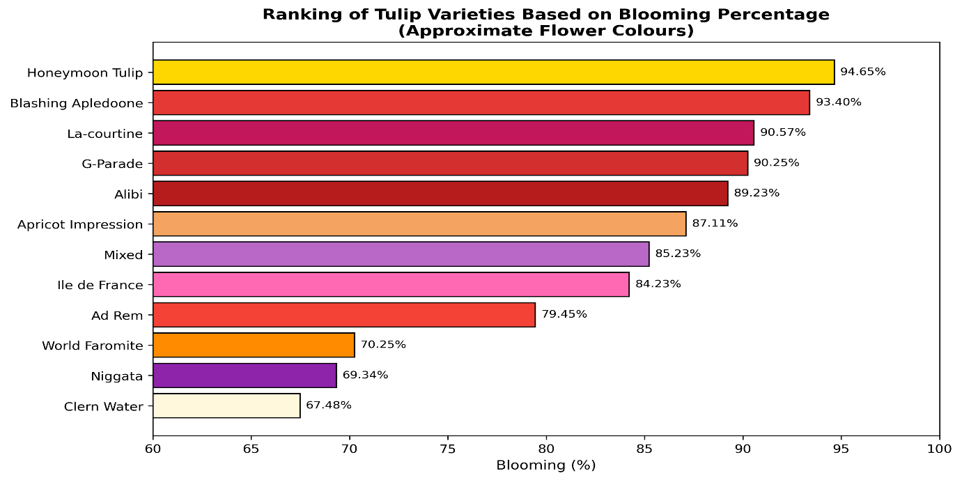
Fig 2: Ranking of tulip varieties based on blooming percentage
Varieties

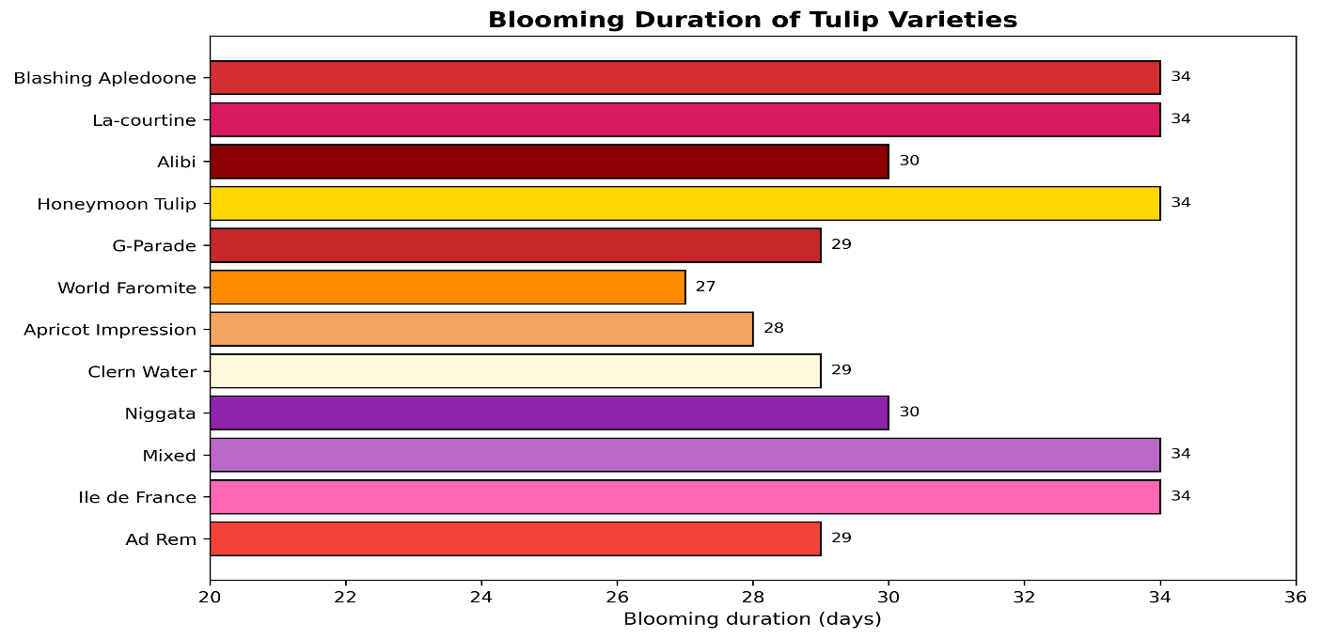
Fig 3: Ranking of Tulip Varieties on Basis of Blooming Duration

Varieties

Table 1: Flowering Phenology of Tulip Varieties Evaluated under the Agro-Climatic Conditions of Gurez Valley
Variety | Flowering Initiation | Peak Flowering* | Flowering Cessation | Blooming Duration (Days)
Blashing Apledoone | 13-04-2026 | 29-04-2026 | 16-05-2026 | 34
La-courtine | 13-04-2026 | 29-04-2026 | 16-05-2026 | 34
Alibi | 21-04-2026 | 05-05-2026 | 20-05-2026 | 30
Honeymoon Tulip | 13-04-2026 | 29-04-2026 | 16-05-2026 | 34
G-Parade | 16-04-2026 | 30-04-2026 | 14-05-2026 | 29
World Faromite | 21-04-2026 | 04-05-2026 | 17-05-2026 | 27
Apricot Impression | 17-04-2026 | 30-04-2026 | 14-05-2026 | 28
Clern Water | 16-04-2026 | 30-04-2026 | 14-05-2026 | 29
Niggata | 21-04-2026 | 05-05-2026 | 20-05-2026 | 30
Mixed | 13-04-2026 | 29-04-2026 | 16-05-2026 | 34
Ile de France | 13-04-2026 | 29-04-2026 | 16-05-2026 | 34
Ad Rem | 19-04-2026 | 03-05-2026 | 17-05-2026 | 29
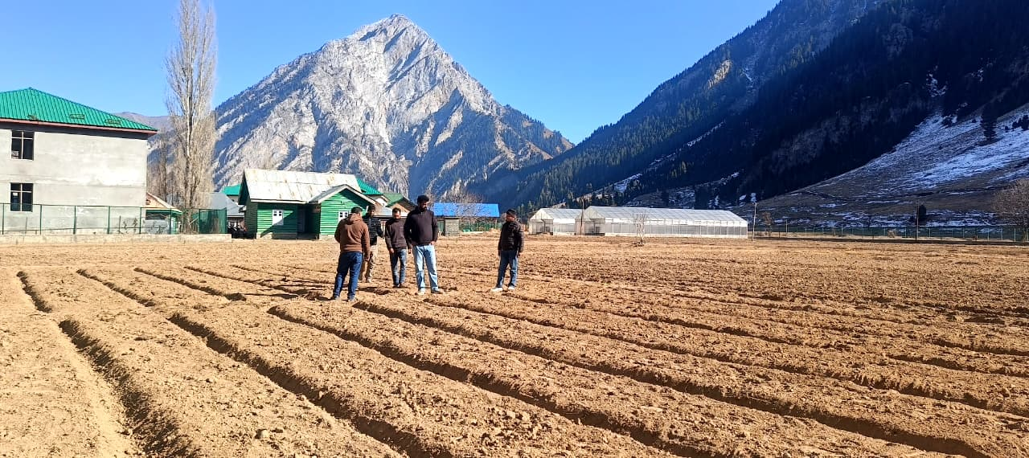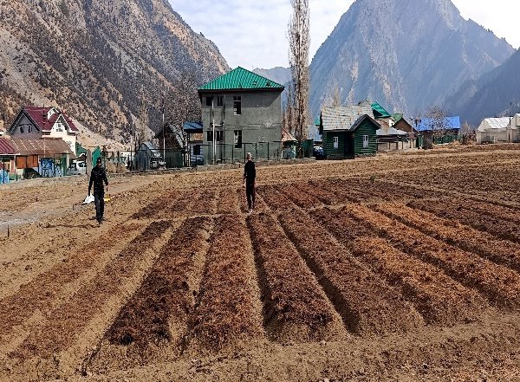
Field Preparation and Sowing of Tulip Bulbs

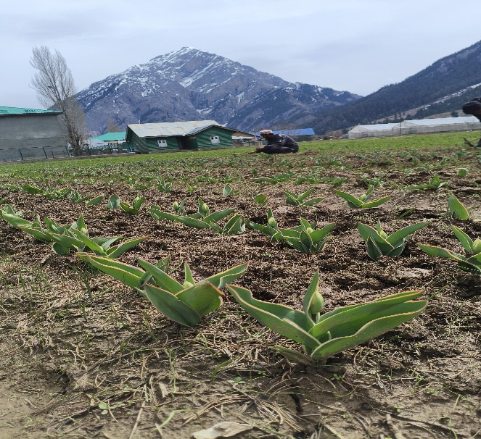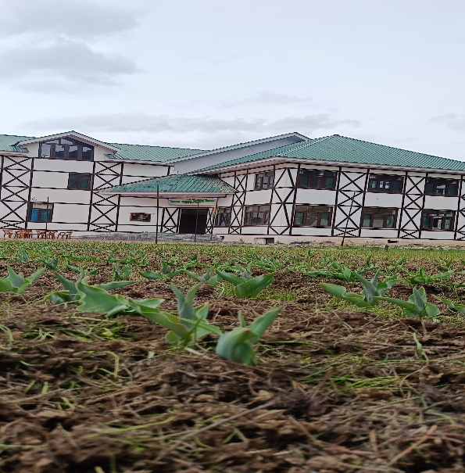
Sprouting of Tulip Bulbs

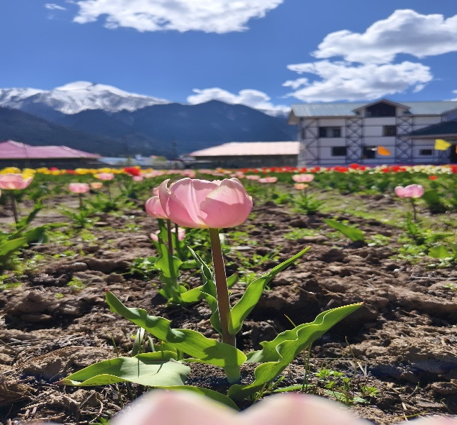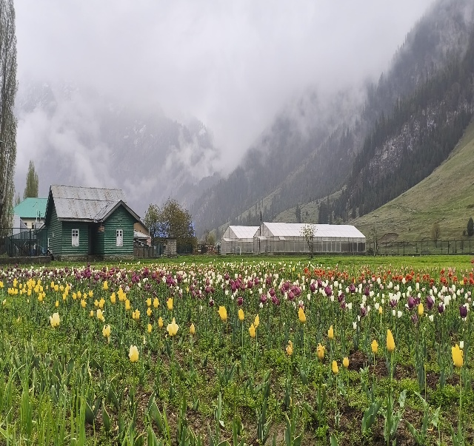
Flowering of Tulips

Visit of the dignitaries to observe the Spring’s Tulip Promise
The Tulip Initiative at KVK/MAR&ES Gurez received significant recognition during the visit of the Hon'ble MLA Gurez, Jenab Nazir Ahmad Khan (Gurezi), District Development Commissioner, Bandipora, Ms. Indu Kanwal Chib (JKAS).
The dignitaries were given an insight about the efforts taken by KVK Gurez for revival of heritage crops , dissemination of novel technologies and introduction of innovative initiatives especially in the backdrop of establishment of first ever tulip yard.
The dignitaries appreciated the initiative as a pioneering step towards agricultural diversification, floriculture promotion, and sustainable livelihood generation in Gurez Valley. They also commended the University's farmer-centric interventions, including the revival of heritage crops and promotion of Kala Zeera, and encouraged the KVK team to continue introducing innovative technologies for the socio-economic development of the region.
Tulips and Eco-Tourism
Blending Natural Beauty with Sustainable Rural Development
Gurez Valley is renowned for its spectacular landscapes, snow-capped mountains, alpine meadows, crystal-clear rivers, and rich cultural heritage. Every year, the valley attracts nature lovers, adventure enthusiasts, and tourists seeking an authentic Himalayan experience. The introduction of tulip cultivation adds a new dimension to this tourism potential by combining natural beauty with ornamental horticulture.
Across the world, blooming tulip fields have become iconic tourist attractions that generate significant economic activity. Seasonal flower festivals draw thousands of visitors, benefiting local communities through increased demand for accommodation, transportation, handicrafts, food services, and other tourism-related activities. Similar opportunities exist in Gurez, where the vibrant colours of tulips can further enhance the valley's scenic charm.
The Tulip Demonstration Yard established at KVK/MAR&ES Gurez serves as the first step towards exploring the integration of floriculture with eco-tourism. During the flowering season, the demonstration plots can attract researchers, students, tourists, photographers, and policymakers interested in witnessing the successful cultivation of tulips under high-altitude conditions. Such visits also provide an opportunity to showcase the University's scientific achievements and extension efforts.
Importantly, the promotion of tulip-based tourism should follow principles of environmental sustainability. Eco-friendly infrastructure, responsible tourism practices, waste management, and active participation of local communities will be essential to preserving the valley's fragile ecosystem while maximizing economic benefits.
By integrating floriculture with tourism, Gurez has the potential to establish a distinctive identity as a Himalayan destination where natural beauty, cultural heritage, and scientific innovation come together to create sustainable development opportunities.

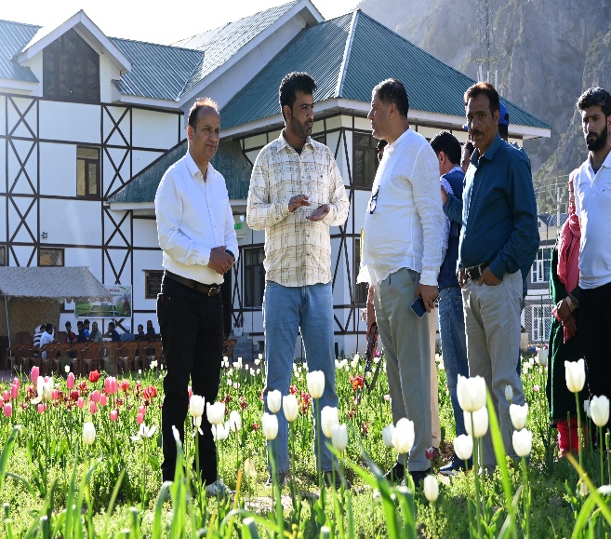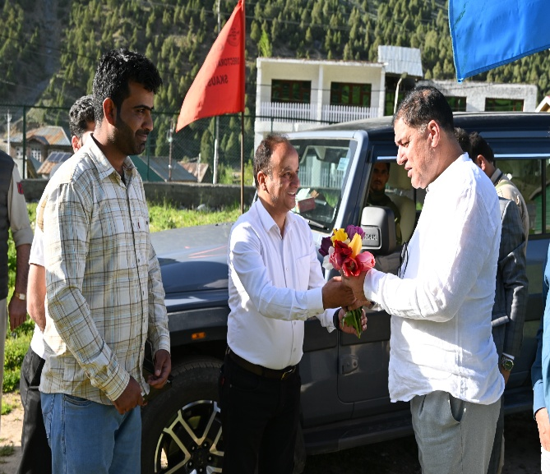
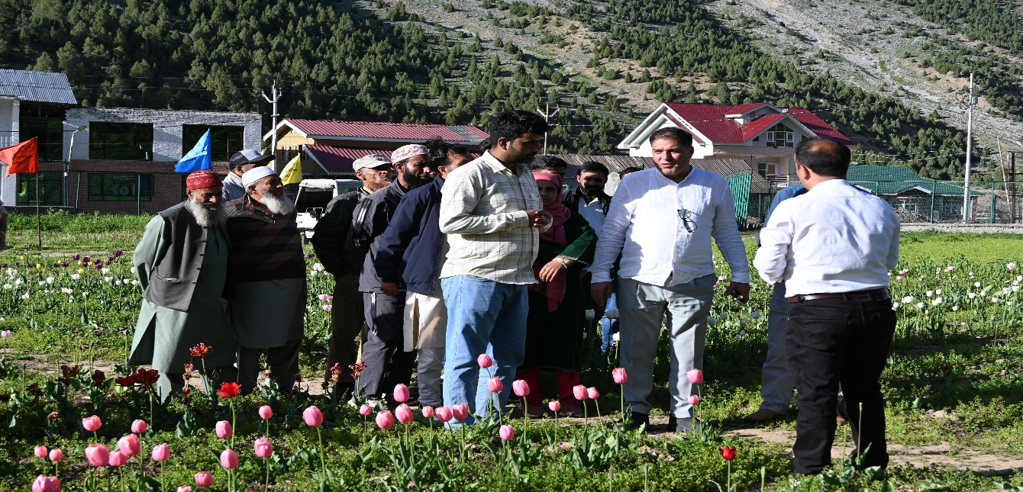
Hon’ble MLA Gurez visiting Tulip yard at KVK Gurez

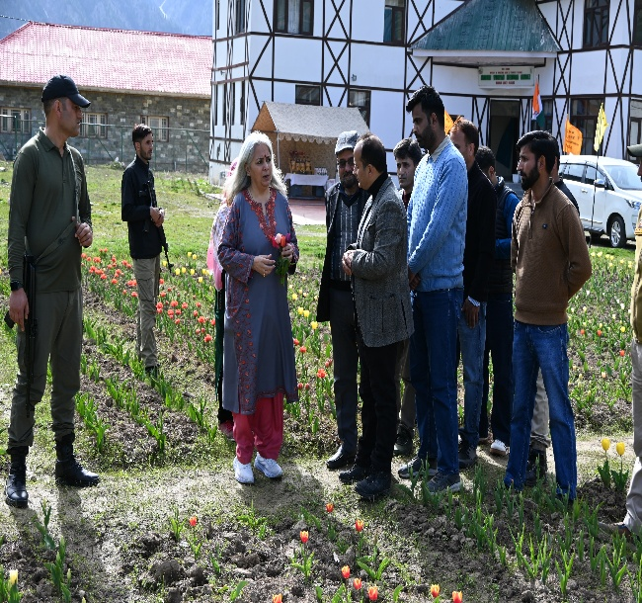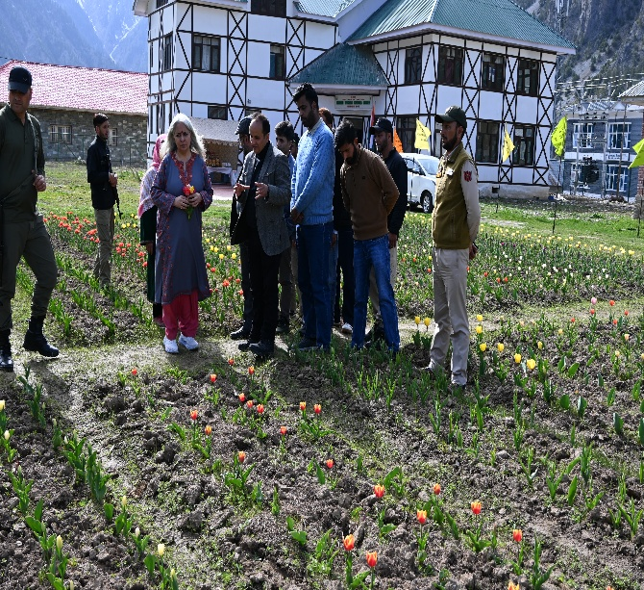
Worthy Deputy Commissioner Bandipora visiting Tulip yard at KVK Gurez

Potential for Bulb Production
A New Opportunity for High-Value Floriculture in Gurez Valley
One of the most promising aspects of introducing tulips in Gurez Valley is the possibility of developing the region as a centre for quality tulip bulb production. While the colourful blooms capture immediate attention, the real commercial value of tulips lies in the production of healthy, high-quality bulbs, which serve as planting material for subsequent cultivation. Globally, the bulb industry forms the backbone of commercial tulip production and contributes significantly to the floriculture economy.
The Tulip Demonstration and Feasibility Yard established at KVK/MAR&ES Gurez has been designed to assess not only flowering performance but also the quantity and quality of daughter bulbs produced under local conditions. Parameters such as bulb size, weight, multiplication rate, health, and storage quality are being systematically monitored to determine the commercial viability of bulb production. So far ongoing feasibility studies produce encouraging results, promising the area to serve as an important centre for tulip bulb multiplication in Jammu and Kashmir. Local production of planting material would reduce dependence on imported bulbs, lower production costs for growers, and ensure the availability of quality bulbs suited to local environmental conditions. Furthermore, commercial bulb production is believed to create new opportunities for rural entrepreneurship, employment generation, and income diversification among tribal farming communities.
Future Roadmap
Towards a Centre of Excellence in Himalayan Floriculture
The successful establishment of the first Tulip Demonstration and Feasibility Yard represents the beginning of a long-term vision rather than the completion of a single project. Building upon the encouraging initial results, KVK/MAR&ES Gurez and SKUAST-K aim to expand scientific research, technology dissemination, and farmer participation to establish Gurez Valley as an emerging centre for temperate floriculture.
Future efforts will focus on evaluating additional tulip varieties, improving bulb multiplication techniques, and developing location-specific production technologies suited to the valley's environmental conditions. Continued research will help identify varieties with superior flowering performance, adaptability, and commercial value.
Capacity building will remain a key priority. Training programmes, demonstrations, exposure visits, and farmer-scientist interactions will be organized to enhance farmers' knowledge and encourage the adoption of floriculture as a supplementary enterprise. Special emphasis will be placed on involving women and rural youth in floriculture-based entrepreneurship.
The University also envisages to integrate tulip cultivation with eco-tourism by promoting floral landscapes, seasonal exhibitions, and community participation in tourism-related activities. Collaboration with government departments, tourism agencies, and local institutions will be essential to realizing this vision.
In the long term, successful research outcomes may facilitate the establishment of commercial bulb production units, community nurseries, and farmer producer organizations dedicated to ornamental horticulture. Such initiatives can significantly enhance rural employment and contribute to the economic development of Gurez Valley.
The Tulip Initiative is therefore envisioned as a catalyst for transforming mountain agriculture through innovation, research, and sustainable livelihood generation. It reflects the University's commitment to empowering remote tribal communities while conserving the ecological integrity of the Himalayan landscape.

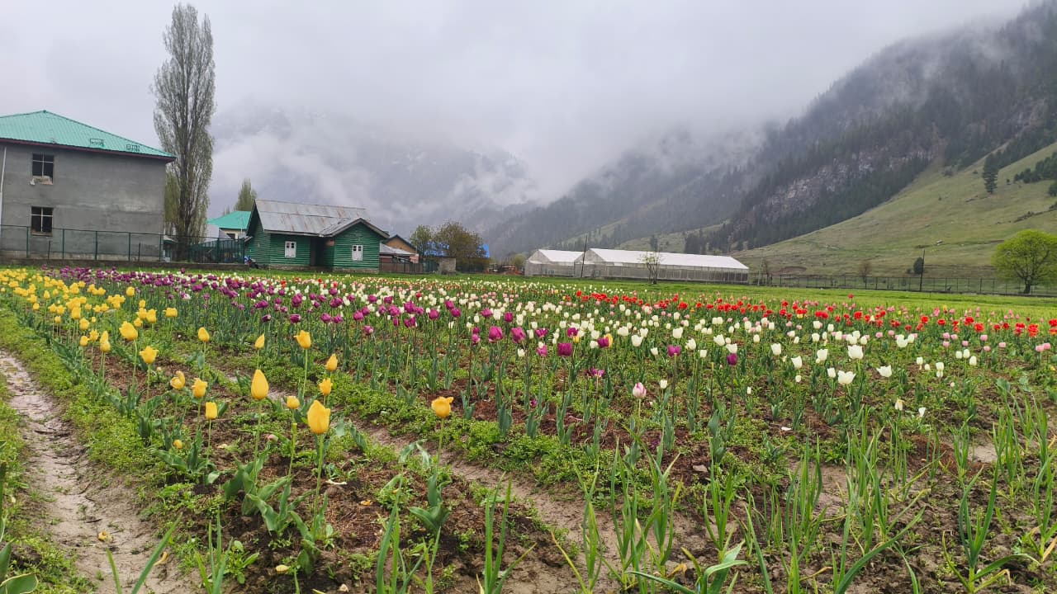

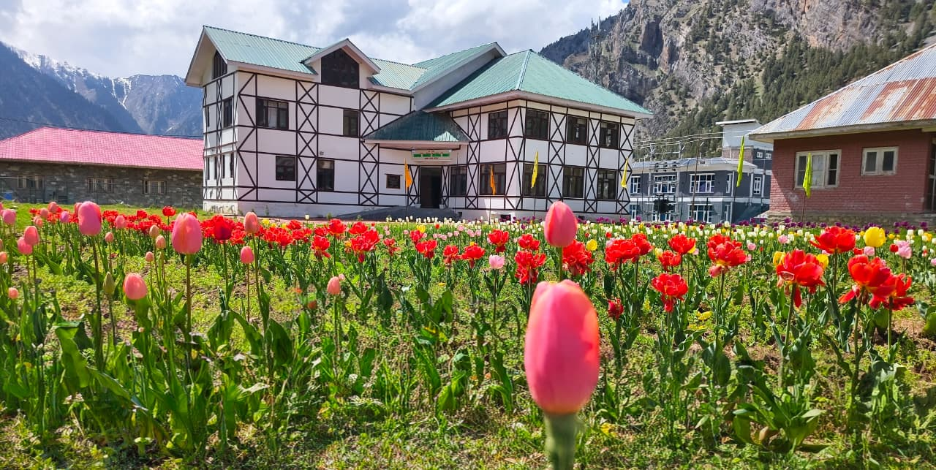
Blooming Tulips at KVK Gurez

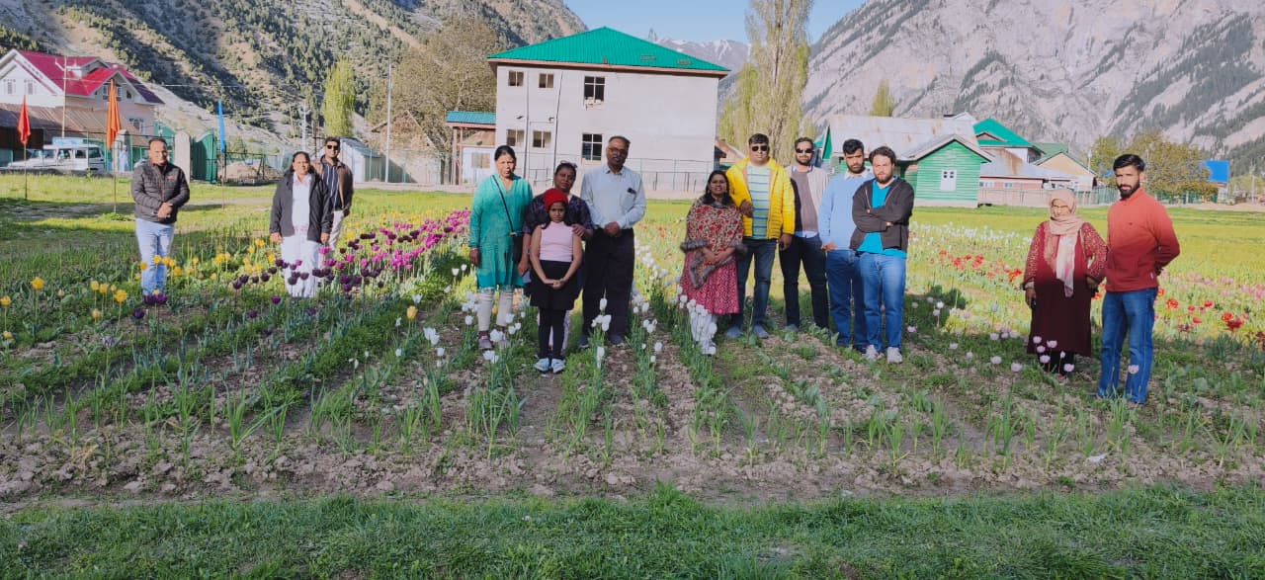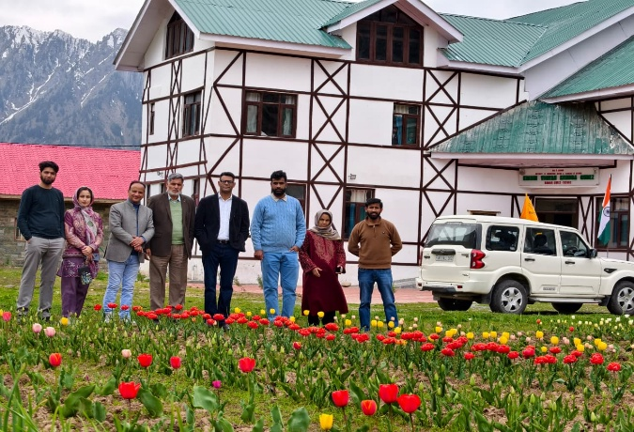
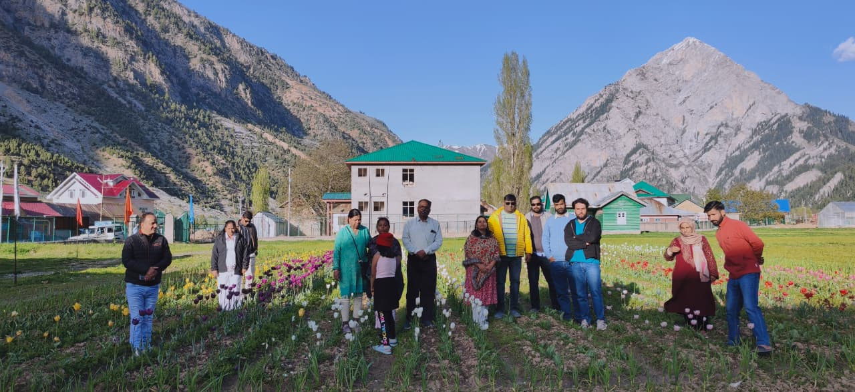

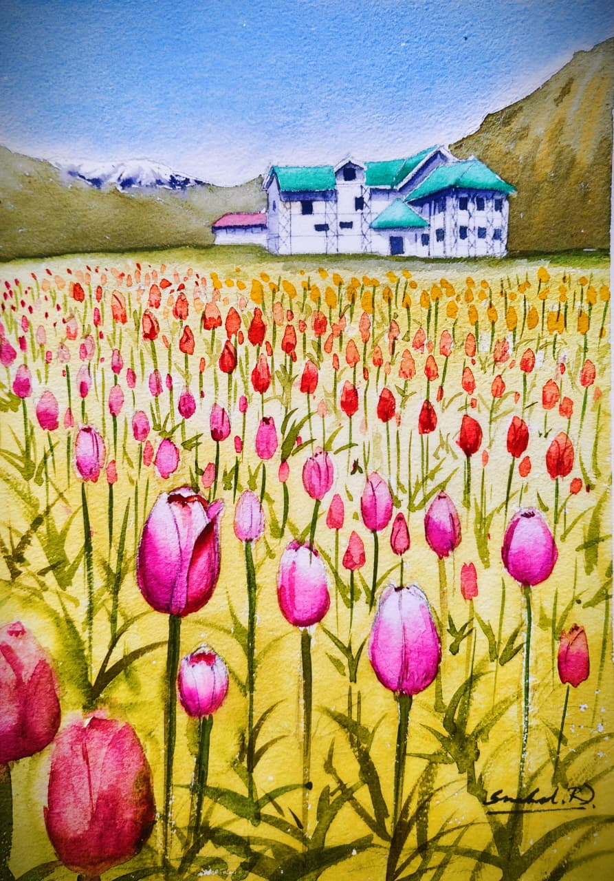
Tulips Through the Visiting Artist's Eyes
Acknowledgements
The successful introduction of tulip cultivation in Gurez Valley is the result of visionary leadership, institutional collaboration, scientific excellence, and dedicated teamwork. KVK/MAR&ES Gurez expresses its profound gratitude to Prof. Nazir Ahmad Ganai, Hon'ble Vice Chancellor, SKUAST-K, whose vision for promoting innovation and high-value agriculture in remote tribal regions inspired this pioneering initiative. The Kendra remains deeply indebted to his exemplary leadership, dynamic vision, and unwavering faith in the capabilities of its scientists and field functionaries, which continue to inspire us to pursue excellence in serving the farming community.
We sincerely acknowledge the constant encouragement, guidance, and support of Prof. Raihana Habib Kanth, Director Extension, SKUAST-Kashmir, whose motivation and commitment to strengthening extension services have been instrumental in the successful implementation of this programme.
We also express our heartfelt gratitude to the Director, ATARI Zone-I, Ludhiana, and the entire ATARI team for their invaluable institutional support, including infrastructural assistance, research facilitation, and continuous guidance that significantly strengthened the activities of KVK Gurez.
Our sincere appreciation is extended to the Directorate of Research, SKUAST-Kashmir, the Centre of Excellence on Tulips, Prof. Imtiyaz Nazki, Head, Division of Floriculture, Landscaping and Architecture (FLA), Faculty of Horticulture, SKUAST-Kashmir, for providing technical expertise, scientific guidance, and quality planting material that made the establishment of the first Tulip Demonstration and Feasibility Yard in Gurez Valley possible.
It is our sincere hope that this pioneering initiative will inspire future generations of researchers, farmers, policymakers, and development practitioners to continue working towards a prosperous, resilient, and sustainable Himalayan agriculture, where innovation blossoms alongside nature for the benefit of society.

Team KVK/MAR&ES Gurez

Editors:

Dr. Hilal Ahmad Malik
Head KVK/MAR&ES Gurez

Dr. Jauhar Rafeeq
Scientist (Agroforesty)

Dr. Shahida Altaf
Scientist (Plant protection)

Mr. Ravi Kumar
(Farm Manager)

Mr. Manzoor Ahmad Khatana
Programme Assistant (lab)

Mr. Tanzeer Hussain Khan
Programme Assistant (Computers)

Ms. Munazah Khalil
(FCLA)

Ms. Rafiya Hassan
(FCLA)

Printing
Mr. Suhail Subhan

Krishi Vigyan Kendra Gurez

Directorate o Extension

Sher-e-Kashmir University of Agricultural Sciences and Technology of Kashmir

